**2019B.Nadav.Peleg - SmartCart Project (04/06/2019)**

***Integrative Software Engineering 10141***

**Students:**

* Nadav Peleg - *209205434*.
* Liad Khamdadash - *313299877*.
* Amit Pelerman - *203518006*.
* Aviel Ben Shalom - *311315006*.
* Nofar Uliel - *312428410*.

**Table of Contents**

**Project Requirements Document** **3**

**Introduction** **3**

General description of the project, the vision, and objectives of the software 3

1.1 Purpose of System 3

1.2 Scope of System 3

**Actors and goals** **4**

**Functional Requirements** **4**

Use Case Diagram 4

Use Case Details 5

**Non Functional Requirements** **8**

**Elements and Actions in our Project** **9**

**2. Appendix A - Project Progress Report** **10**

Kanban Boards 10

List of Team Members 11

General summary of work 12

**3. Appendix B - Project Conclusions Report** **13**

All Kanban Boards 13

Project summary of work 18

**4. Appendix C - Technology Usage** **21**

**5. Appendix D - Installations Guide** **22**

Installing the java spring server with maven 22

Installing MongoDB 32

Installing the react web client 36

Installing the socket server 39

Installing the android client 40

Additional configurations for client and server 41

**6. Appendix E - Clients Screenshots** **43**

Web Client - For Players and Managers 43

Android Client - For Admins 47

# 

# 

# 

# Project Requirements Document

# Introduction

## *General description of the project, the vision, and objectives of the software*

SmartCart is an application that will let users create collaborative shopping lists. Managers will be able to create lists, items and add members to list. each user will be able to mark items as bought so other members will know not to buy them again.

The idea behind SmartCart is to provide families with a solution for gathering all their shopping needs into one easy-to-access list, thus eliminating incidents such as your wife being angry on you when you forget to buy her shampoo.

Our vision:

* The app will be the main platform for shared shopping lists in two years.
* At least 10,000 daily active users after one year

## *1.1 Purpose of System*

The system purpose is to create one place for friends and family to share and edit their shopping list. SmartCart will save time and make sure each member of the list gets exactly what they asked for.

## *1.2 Scope of System*

***In scope:***

* The system will support only the English language.
* The system will allow the manager to create shopping lists.
* The system will allow the manager to add new shopping items
* The system will allow the manager to add list members.
* The system will allow players to mark items in their shared lists as “bought”.
* The system will show each list’s online members (check in / check out)
* The system will allow admins to import or export user, elements and actions.

***Out of scope:***

* The system will not provide online delivery option for added items.
* The system will not provide external notifications for list changes.
* The system will not provide an option to undo profile edits.
* The system will not check the authenticity of list items.

# Actors and goals

|  |  |  |  |
| --- | --- | --- | --- |
| **Actor** | **Role** | **Description** | **Goals** |
| Manager | Primary | The manager is the person that opens the shopping list, the manager has full privileges and can create elements. | Invite users to join a shopping list and add items to lists. |
| Player | Primary | A normal user that can be invited to join a list and invoke actions. | mark items as “bought”, invoke check in or check out |
| Admin | Primary | Import or export users, elements and actions. | Import from other smartspace or export to another smartspace |

# Functional Requirements

## *Use Case Diagram*

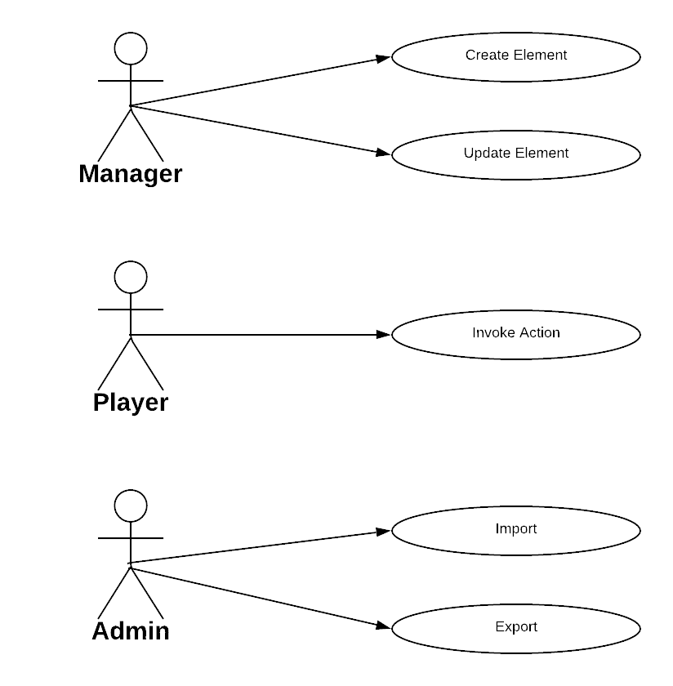

## *Use Case Details*

***3.2.1)*** *Use Case:* Create Element

*Participating actors:* Manager

*Goals:* The manager creates a new Element.

*Main flow*:

1. Manager chooses to create a new element

2. Manager enters element details

3. System validates element details

4. System saves the element to the database

*Alternate flow*:

1a1. Manager creates a new shopping list.

1a2. The flow continues at step 3.

1b1. Manager creates a new item in a shopping list.

1b2. The flow continues at step 3.

4a1. Element validation fails.

4a2. The manager receives an error message.

***3.2.2)*** *Use Case:* Update element

*Participating actors:* Manager

*Goals:* The manager updates an existing element.

*Main flow*:

1. Manager views an existing element and chooses to update it.

2. Manager enter the new updated details.

3. Manager confirms update the element.

4. System updates the element with all its contents.

*Alternate flow*:

1a1. Manager adds a new member to a list by editing the members attribute

1a2. The flow continues at step 3

4a1. Manager tried to update element with non existing key

4a2. System returns an error message

***3.2.3)*** *Use Case:* Invoke action on element

*Participating actors:* Player

*Goals:* Players can invoke new actions on existing element that will change it, actions can also change the user’s points.

*Main flow*:

1. Player submits a new action

2. System validates action details

3. System processes the action making changes on element if necessary

4. Player gain or lose points.

5. System saves the action to the database.

*Alternate flow*:

1a1. Player marks item as bought.

1a2. The flow continues at step 2.

1b1. Player checks in the member displayer.

1b2. The flow continues at step 2.

1c1. Player checks out from the member displayer.

1c2. The flow continues at step 2.

3a1. Action is not valid.

3a2. System returns an error message.

***3.2.4)*** *Use Case:* Import data to smartspace.

*Participating actors:* Admin.

*Goals:* The admin import elements, actions or users from another smartspace.

*Main flow*:

1. Admin inserts elements/actions/users to import.

2. System validates each of the items.

3. System saves all import data to database.

*Alternate flow*:

1a1. Admin chooses to import elements, actions or users via the mobile app.

1a2. System asks admin to choose a text file.

1a3. The flow continues at step 2.

3a1. at least one of the items is not valid

3a2. The import fails (nothing is imported) and the admin receives an error message.

***3.2.5)*** *Use Case:* Export data from smartspace.

*Participating actors:* Admin.

*Goals:* The admin export elements, actions or users from our smartspace.

*Main flow*:

1. Admin chooses elements / actions / users to export.

2. System reads the requested data from the database and returns it as json

*Alternate flow*:

2a1. Admin chose to export data via mobile app.

2a2. Mobile app exports the data and asks on which platform (email \ whatsapp) will the admin want to share it.

2b1. User is not an admin.

2b2. System displays an error message saying that user is not an admin.

# Non Functional Requirements

## 

|  |  |  |
| --- | --- | --- |
| Requirement Number | Requirement Description | Requirement Type (U/R/P/S) |
| 1 | The web app will run on the latest versions of chrome, firefox and edge. | Supportability |
| 2 | Shopping Lists will be loaded in under 6 seconds. | Performance |
| 3 | Error messages will have clear content and be easy to spot. | Usability |
| 4 | Users will get indications for successful actions. | Usability |
| 5 | The system will backup all data at least once per week. | Reliability |
| 6 | The system supports English. | Supportability |

## 

## 

# Elements and Actions in our Project

1. ***Element* - Shopping List**

*Purpose -* create one place to share and edit shopping list.

*Attributes:*

* + - * members (array)
      * onlineIndicator - (the key of the check in check out element)
      * description

*Actions: No actions.*

1. ***Element* - ShoppingItem**

*Purpose -* represent a product that you want to buy.

*Attributes:*

* listKey (the key of the parent ShoppingList element).
* marked (boolean that shows if item was bought).

Actions:

* Mark item status as bought or not bought.

1. ***Element* - Online Indicator**

*Purpose -* Display all members of shopping list and their online status.

Attributes:

* onlineMembers (array)

*Actions:*

* + - * Check In
      * Check Out

# 2. Appendix A - Project Progress Report

## 

## Kanban Boards

24/05/2019

## 

03/06/2019

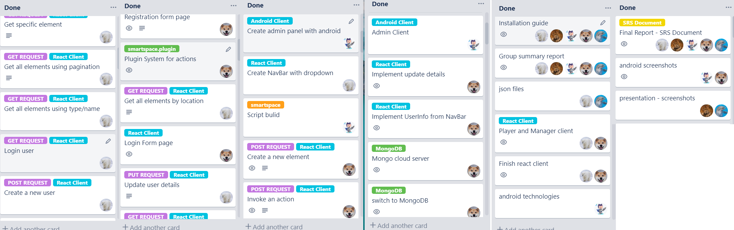

## 

## 

## 

## 

## 

## 

## 

## List of Team Members

|  |  |  |  |
| --- | --- | --- | --- |
| **Name** | **ID** | **Avatar** | **Responsibilities** |
| Nadav Peleg | 209205434 |  | Team Leader, DBA. |
| Liad Khamdadash | 313299877 |  | QA Engineer |
| Amit Pelerman | 203518006 |  | UI/UX Designer. |
| Aviel Ben Shalom | 311315006 |  | Devops Product Manager. |
| Nofar Uliel | 312428410 |  | Technical Writer . |

## 

## 

## General summary of work

*What went well for the team and should be continued on next assignments?*

We finished our project and we are satisfied with the result. always communicate, ask for help when you get stuck. be goal oriented. working with git and trello, or other alternatives, should be continued.

*What should be improved in the teamwork?*

Set more meetings and work together, maybe have a short meeting in the beginning of each phase to recap what needs to be done. especially have meetings when we start including a new technology or when there is a lot of work to be done in a short period of time. also talk more, share ideas, share improvements, share new technologies with each other.

*What problems did the team encountered through the work?*

It was difficult to learn new language in short time.

We had problems to convert our project to maven project but together we solved this problem. MongoDB did a lot of problems with transactions but we figured out how to fix it after a while but we had to change some code.

*Why did we not complete all planned work*

We wanted to put even more features in the client but we didn’t have enough time and decided to do the best we can with the time we do have.

We also wanted to add more tests, more validations and fix some known bugs in the clients but couldn’t due to lack of time.

# 

# 

# 

# 

# 

# 

# 3. Appendix B - Project Conclusions Report

## All Kanban Boards

**Kanban Boards of sprint 1 (ended 12/03)**

**01/03/2019**

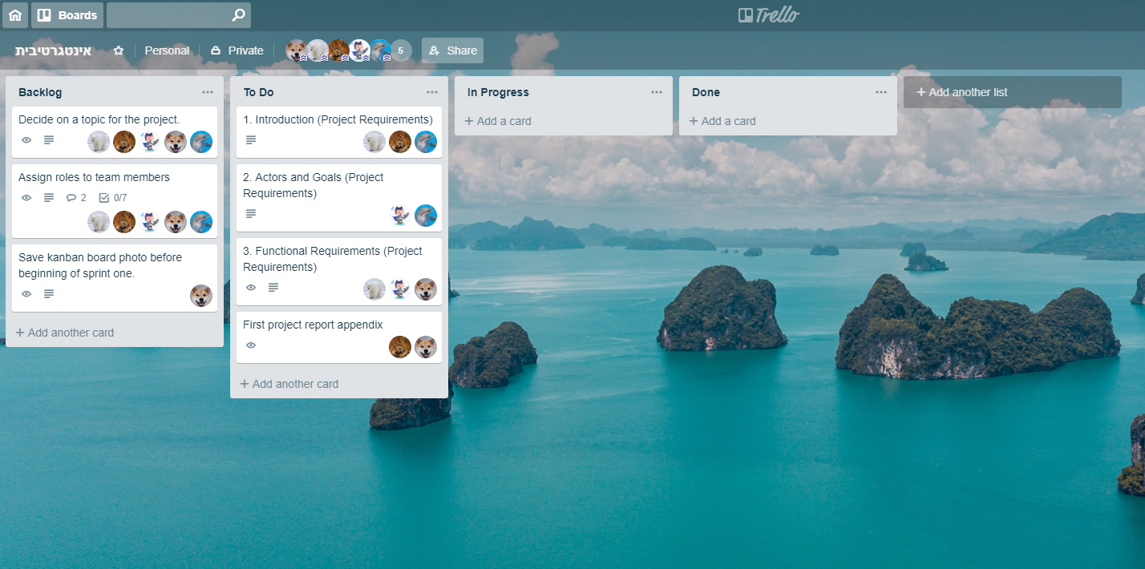

**11/03/2019**

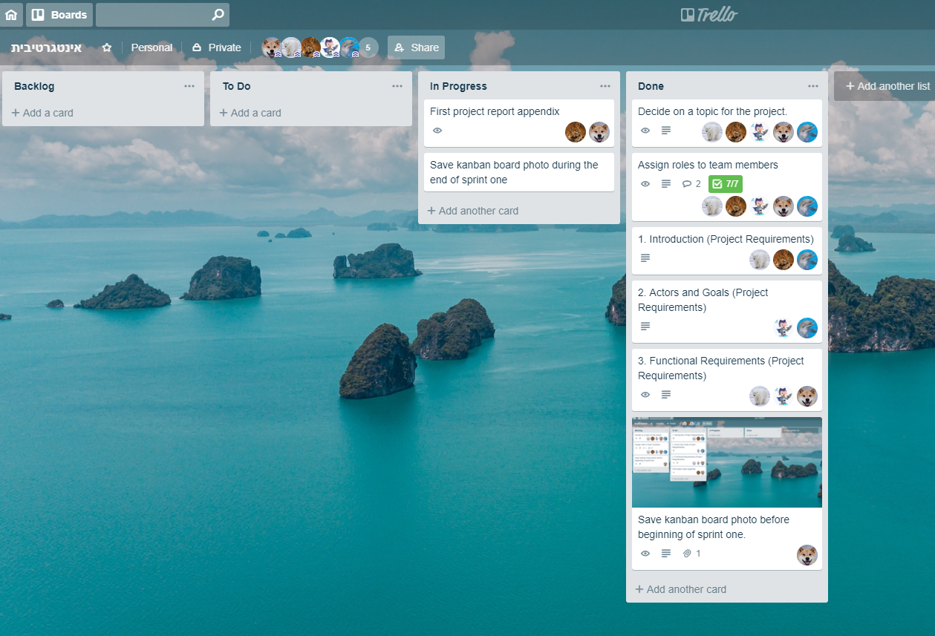

**Kanban Boards of sprint 2 (ended 26/03)**

[in the beginning of this phase:](https://trello-attachments.s3.amazonaws.com/5c88cd353ac80b1581efbeed/1192x780/41063b577c01d4849e5ae535895c36cb/image.png) **(15/03/2019)**

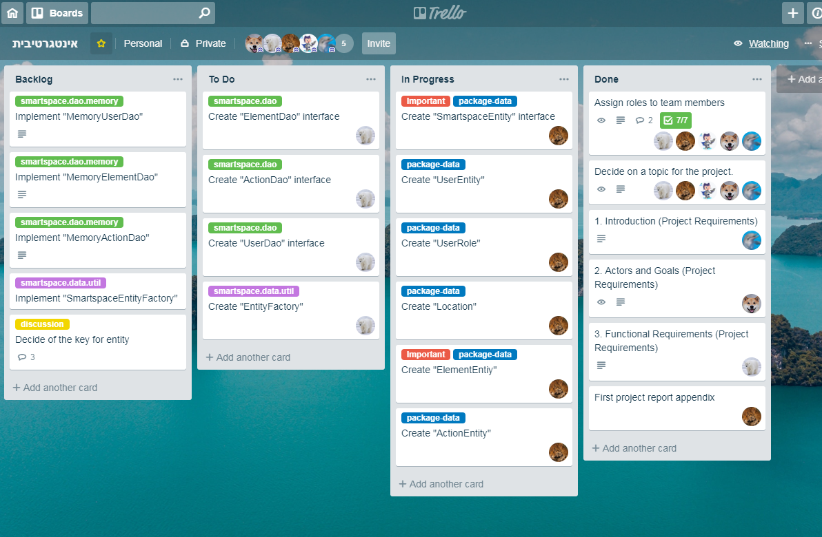

[at the end of this phase:](https://trello-attachments.s3.amazonaws.com/5c74f4728be21405b893d7d8/5c98b15dc457ea1a409637b4/09b9e1f2e06e659beb4ab54eb36b1462/image.png) (25/03/2019)

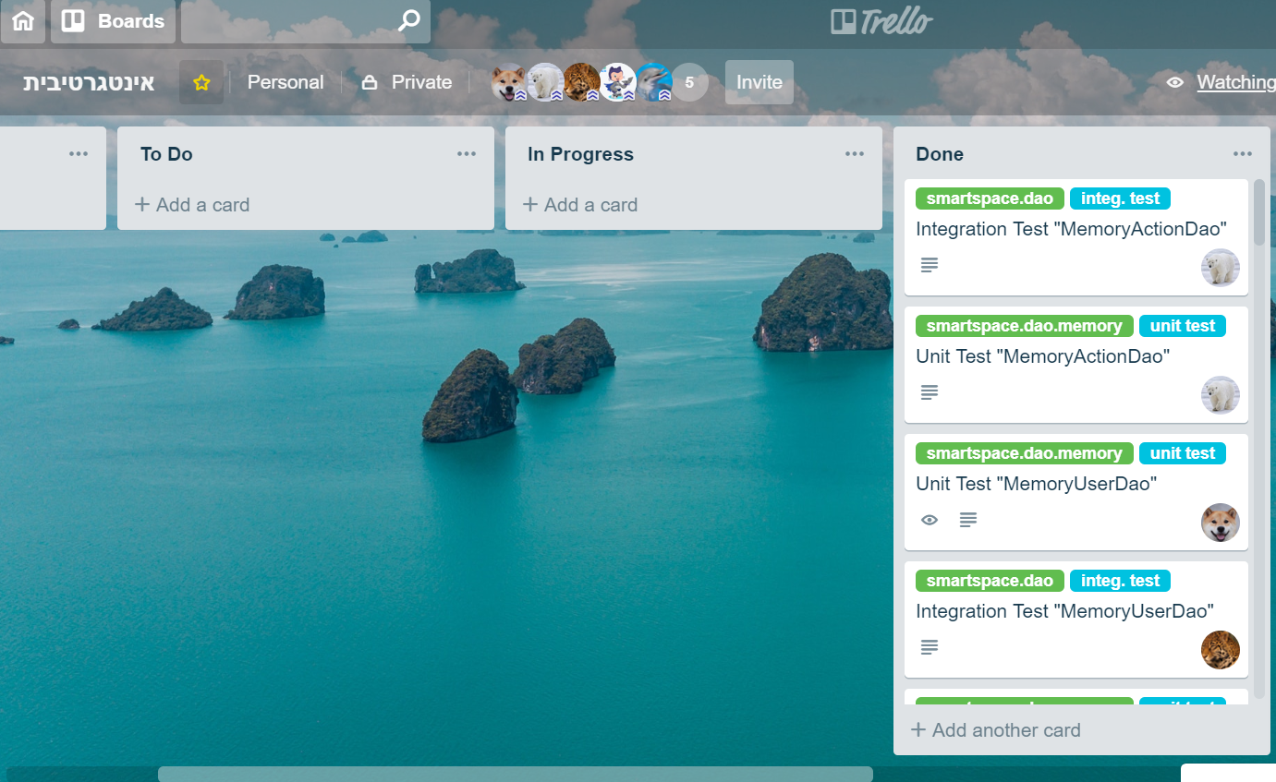

**Kanban Board of sprint 3 (ended 09/04)**

[in the beginning of this phase (27/03/2019):](https://trello-attachments.s3.amazonaws.com/5c74f4728be21405b893d7d8/5ca9fa8c45daa57c0ddc4472/237c75822c3457cdade71f4e332a1681/27-03-2019.png)

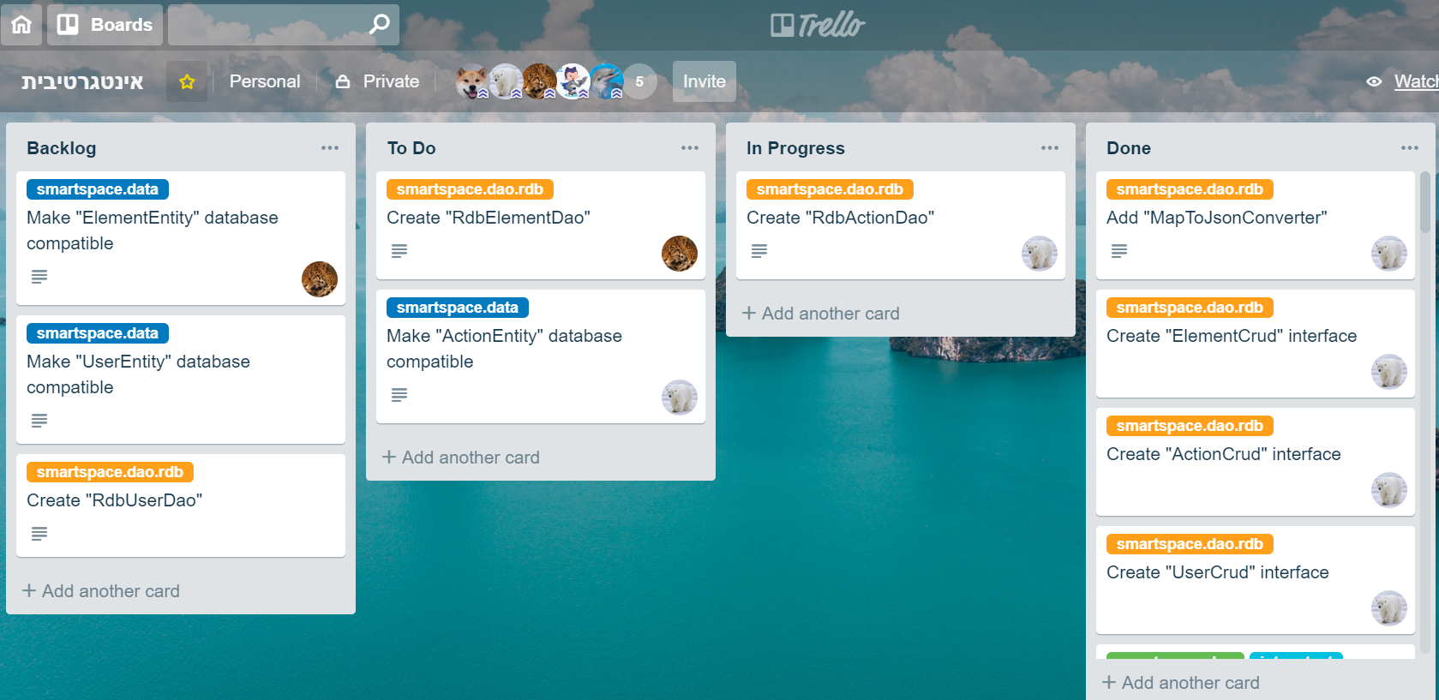

[at the end of this phase (07/04/2019)](https://trello-attachments.s3.amazonaws.com/5c74f4728be21405b893d7d8/5ca9faee4f04820c2e4ed365/d19819039028fa68c07bf45998c8fa89/image.png) - [[1]](https://trello-attachments.s3.amazonaws.com/5c74f4728be21405b893d7d8/5ca9faee4f04820c2e4ed365/d19819039028fa68c07bf45998c8fa89/image.png) [[2]](https://trello-attachments.s3.amazonaws.com/5c74f4728be21405b893d7d8/5ca9faee4f04820c2e4ed365/b64dcde70e7f5e6c6d4864a3ef2e8dd5/image.png) [[3]](https://trello-attachments.s3.amazonaws.com/5c74f4728be21405b893d7d8/5ca9faee4f04820c2e4ed365/b23c33b9cf0774c31f5815e3e64b5418/image.png)

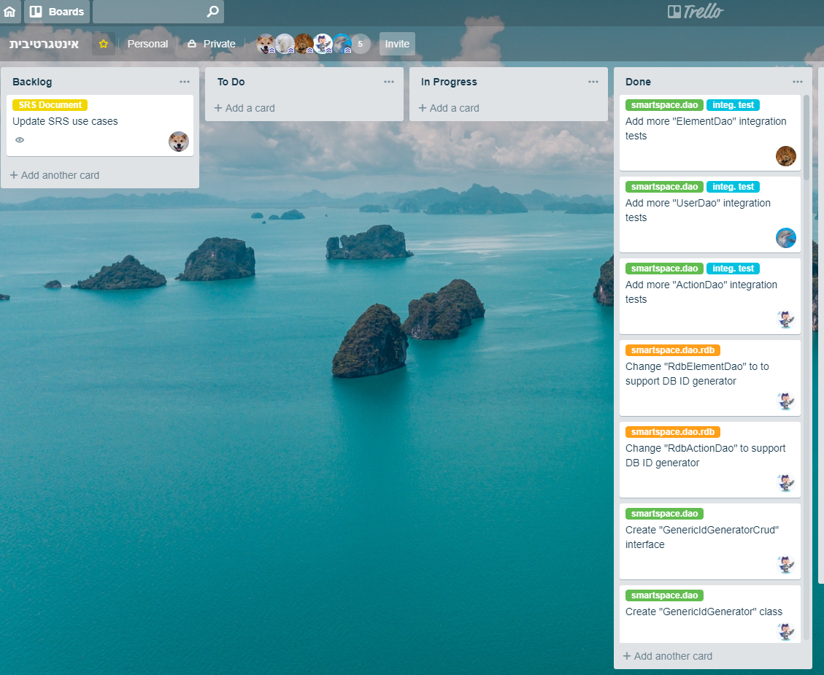

**Kanban Board of sprint 4 (ended 07/05)**

[in the beginning of this phase (18/04/2019):](https://trello-attachments.s3.amazonaws.com/5c74f4728be21405b893d7d8/5cb856a8c4215979d72bd32a/264c0563c9a808a451ddaff08e369dce/image.png)

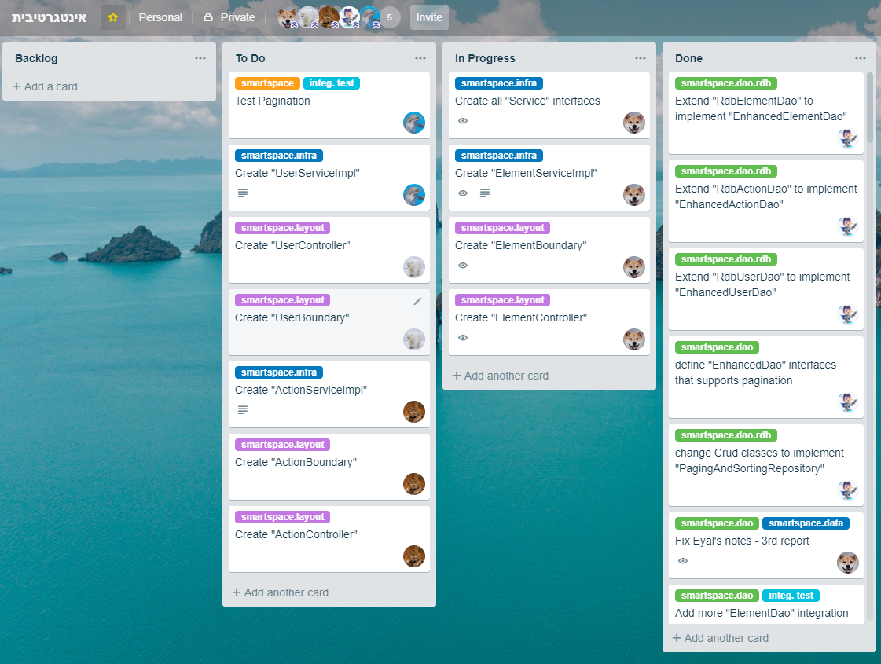

[at the end of this phase - the complete done category (05/05/2019)**:**](https://trello-attachments.s3.amazonaws.com/5c74f4728be21405b893d7d8/5ccdfffadf3754336c9c368b/27b8ac500be18c6c0dd20c0a3e8c79e5/image.png)

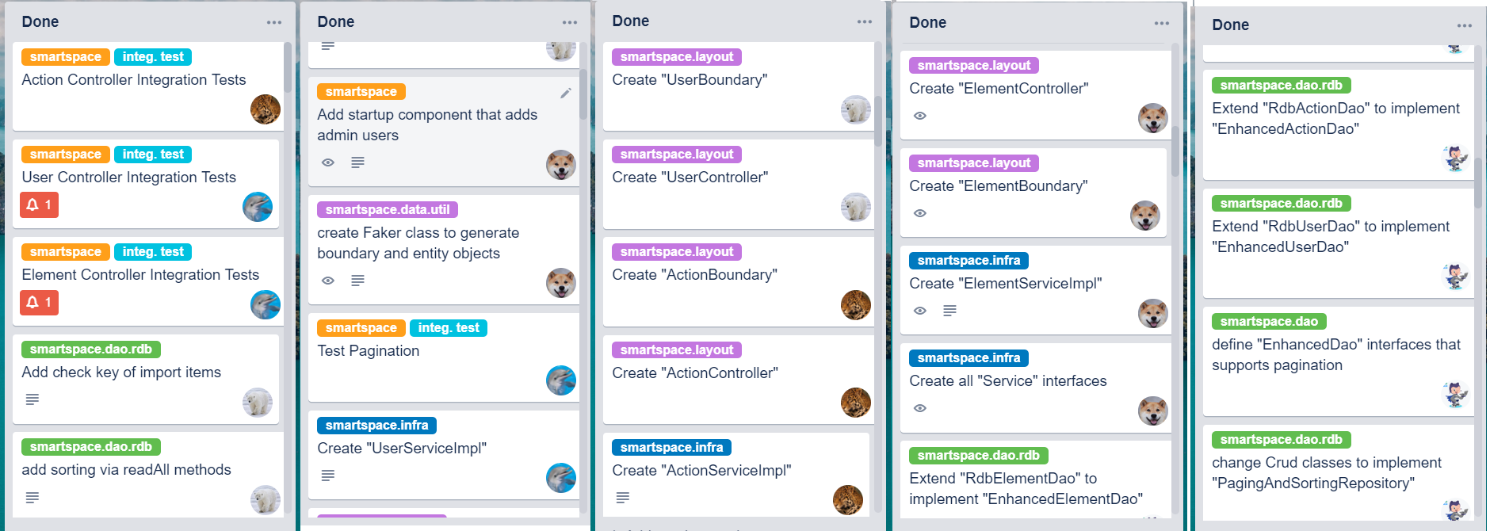

**Kanban Board of sprint 5 (ended 21/05)**

[in the beginning of this phase (08/05/2019):](https://trello-attachments.s3.amazonaws.com/5ce132b66a176103cd4ce0c2/1119x877/540b83d24ab8fd5cb5ff3918cb745992/image.png)

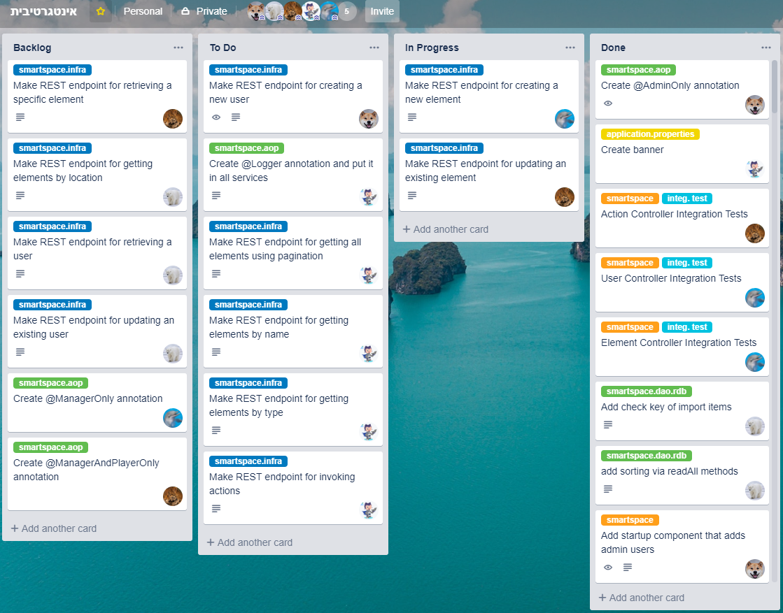

[at the end of this phase - the complete done category (19/05/2019):](https://trello-attachments.s3.amazonaws.com/5c74f4728be21405b893d7d8/5ce1340ce5f8198401f75696/b3a5bacc2358c4690577e2b06adf2ad3/image.png)

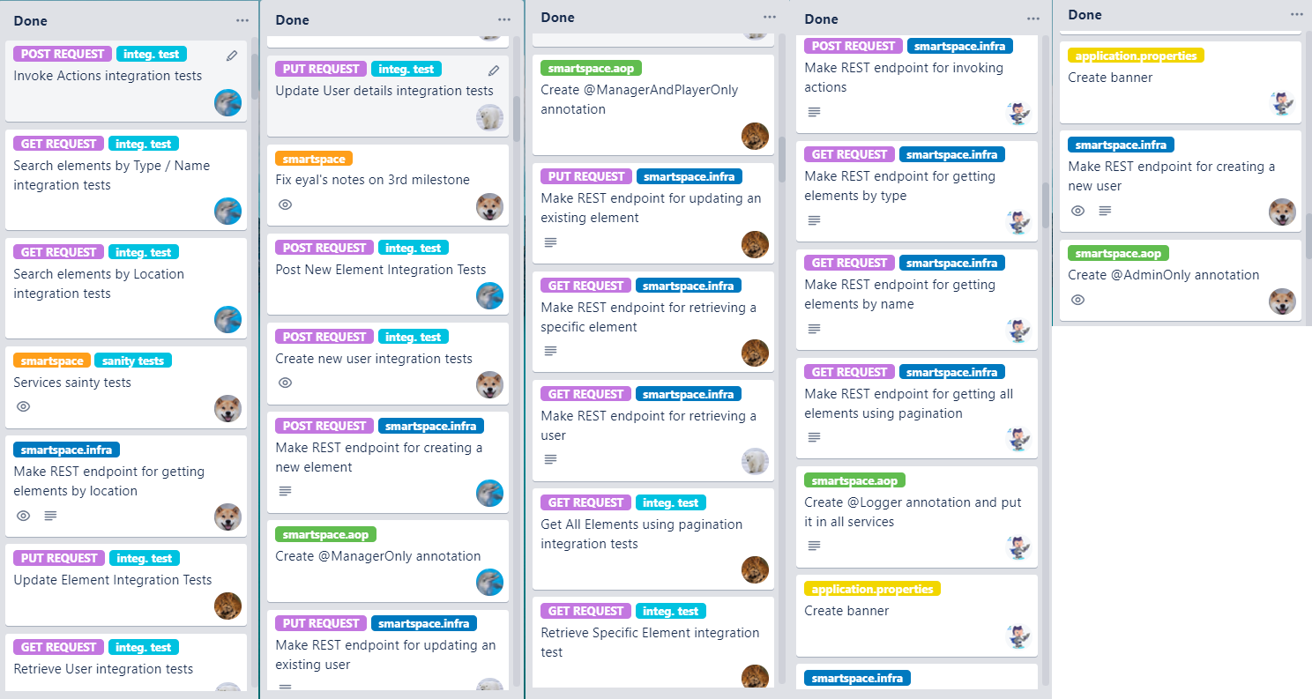

## Project summary of work

*What went well for the team and should be continued in next projects?*

**Liad:**

Backing one another's team when there is pressure of chores, the staff know the material well and that is important. There is a willingness and a constant desire to develop and learn new things.

**Amit:**

we had good communicate and every team member always wanted to do more and contribute to the team.

:**Nofar**

We have for each member list of task so everybody know what he need to do on this week.We had good communication and we worked together.

**Nadav:**

I really liked being able to share my opinions with others and discuss new ideas in person or in the group chat. I also liked working with git it was hard at first but after a while it become easier and I feel like it really helps organize things. the trello board was also very good for organizing things and I would definitely want to use it again in the future.

**Aviel:**

Each member of the group knew what he had to do, we helped each other and   
 made sure that our tasks would be finished on time.

*how will you improve your work in your next projects?*

**Liad:**

Learn more about the technologic we have used before we start to code and divided

the work/responsibilities evenly across all team members before the development process.

**Amit:**

I think I would start with deep understanding the whole structure of the levels and the structure of the project.

:**Nofar**

I will learn more about the technology that i will be use and i will plan my time correctly.

**Nadav:**

Try including new unfamiliar technologies and further improve team work.

**Aviel:**

I will plan my time in order to learn the new technology in a deeper way and to search for for other tools that can make our work on the project much easier.

*what did you enjoy most while working on this project?*

**Liad:**

Coding is always fun and the process of learning and expanding the knowledge of new technologies that we used during development was very enjoyable in my opinion as one who likes to expand knowledge - that will help me in the future.

**Amit:**

The learning of so many new technologies and also the experience in coding the client with React.

:**Nofar**

I enjoyed to learn new technologies every sprint that I didn't know before.

**Nadav:**

I enjoyed learning about new things I didn’t know about, I never would have thought it was possible to do so much things with Java, this course really opened my mind. I also enjoyed working with a database and working on the web client.

**Aviel:**

I enjoyed the cooperation between the group members and to learn some new tools. I found it interesting to use different things that we have learned and to integrate them for one whole purpose.

*what would you have done differently if you could start this project from scratch (with the knowledge and the experience of this semester)?*

**Liad:**

We would divide the work into as many files as possible so that it would be more convenient to develop, and so we would prevent integration problems with each other in the code merger. I would also change the design of the system since at the beginning of development we did not know what to expect for the end of development. And most of all I think I would have started developing the front more early to invest in it more.

**Amit:**

Maybe to start with design and coding the client while we work on the server, we could do it at the same time after we made the SRS.

:**Nofar**

I would have start from writing the client because in that way the requirements would be more understandable.

**Nadav:**

I would have switched to MongoDB much earlier as well as start working on the client, I would also use the plugin system for element search (search by type, search by name, etc).

**Aviel:**

I would start the task with the design and understanding how the client looks like. I would

also start coding it in an earlier stage.

# 

# 4. Appendix C - Technology Usage

*Our work so far has included the usage of the following technologies:*

* Trello
* Git
* SourceTree
* Teamviewer / join.me
* Java
* Spring
* Spring-core
* Spring-test
* Spring-boot
* JUnit
* AssertJ
* H2
* Hibernate
* Spring Data JPA
* Spring-orm
* JDBC
* Jackson
* Tomcat
* Spring-Web
* Java Reflection
* AspectJ
* Maven
* MongoDB

Web client:

* npm
* html, javascript & css
* react, react-router
* axios
* bootstrap
* node.js
* socket.io

Android client:

* SDK
* Volley
* Secure-preferences
* Glide
* Circleimageview

# 5. Appendix D - Installations Guide

## *Installing the java spring server with maven*

1. Download Eclipse IDE with all the extras from the Lecturer Library

(Afeka Moodle).

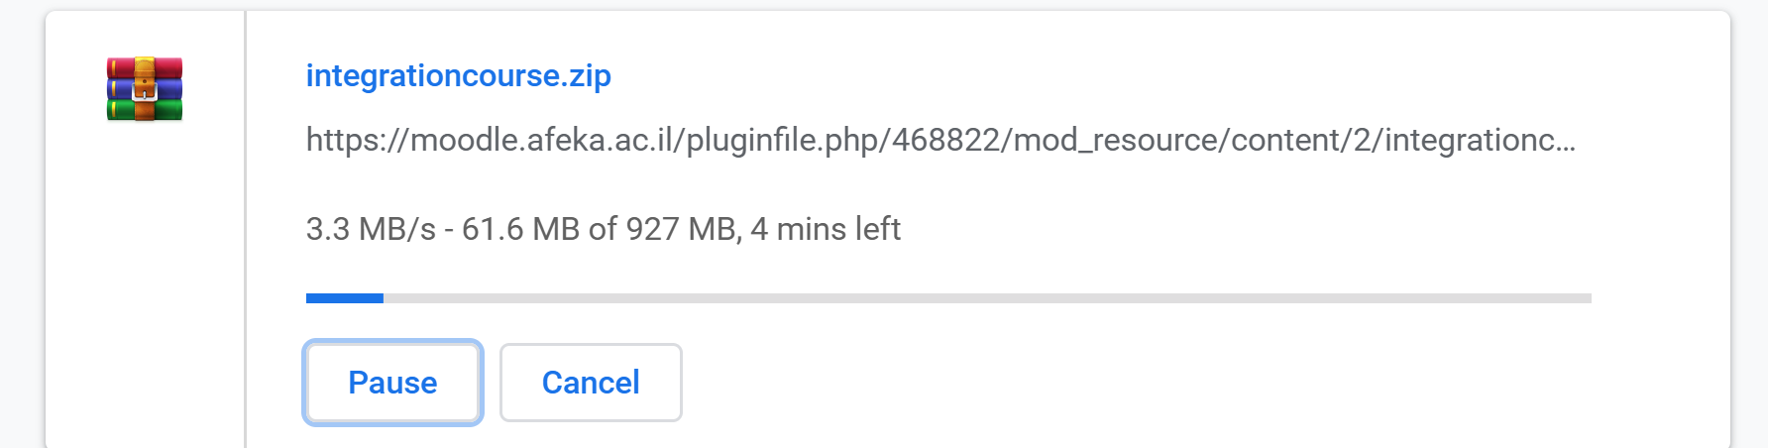

1. Copy the .zip file to C:/directory and extract the files inside
2. Install the Eclipse on the computer
3. Open the eclipse.bat from the directory integrationcourse.

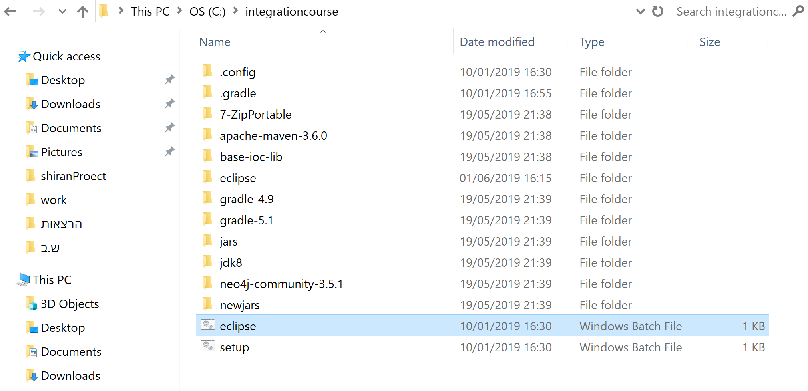

1. Import GIT project from bitbucket:

Choose File -> Import… ->

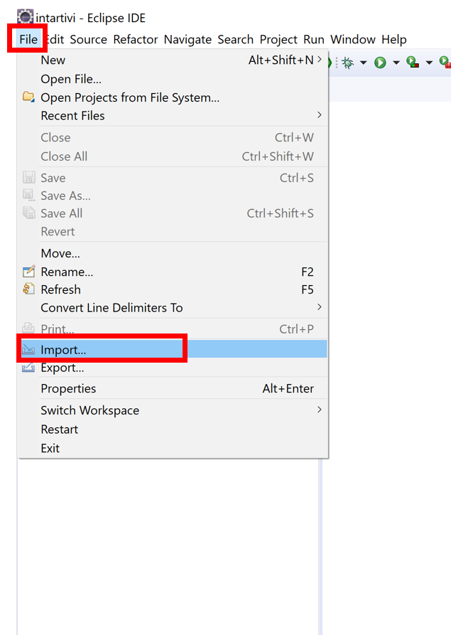

1. Git -> Projects from Git- >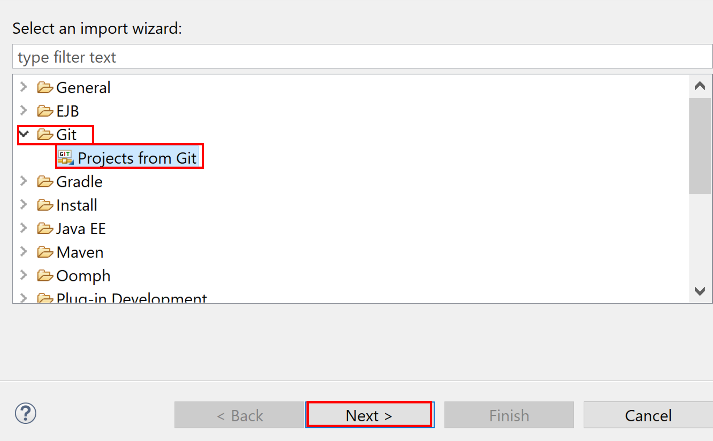
2. Clone URI ->

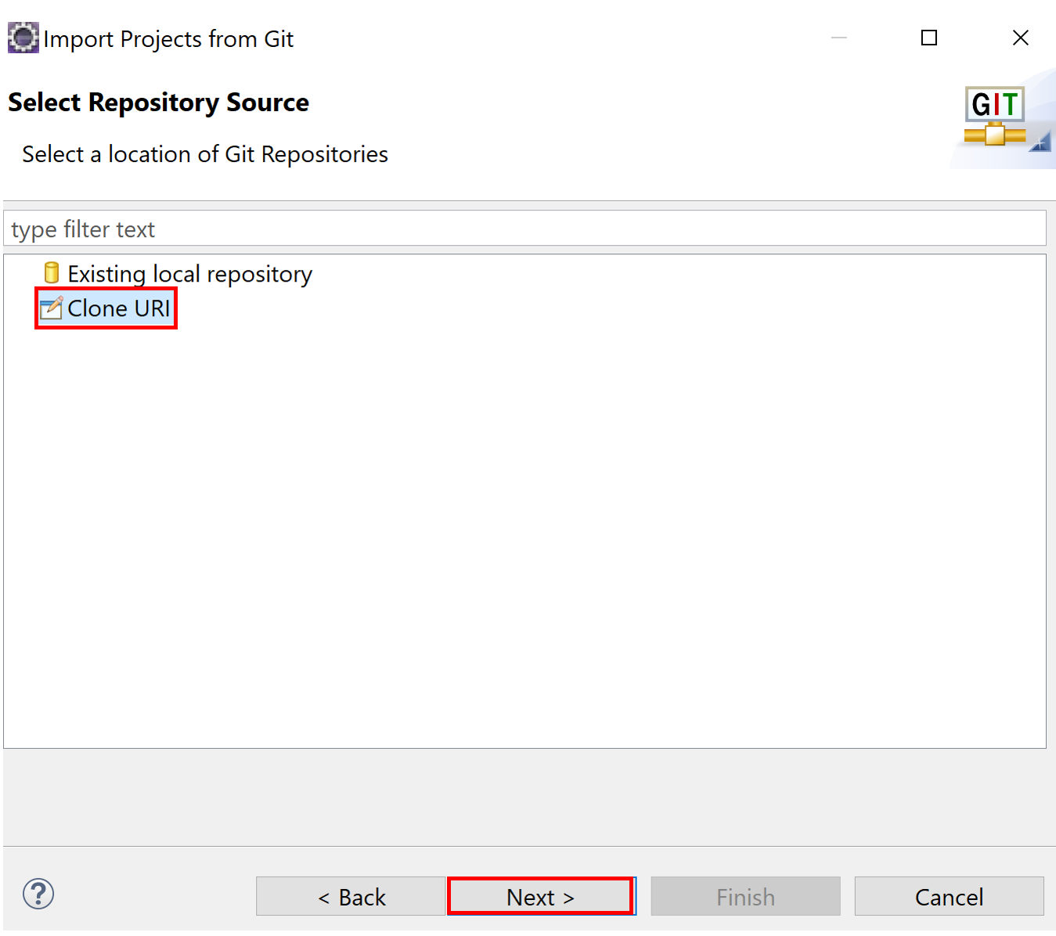

1. Copy the URL from Bitbucket (Project Clone) ->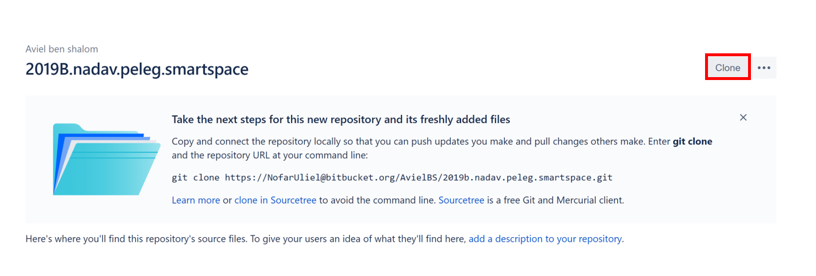

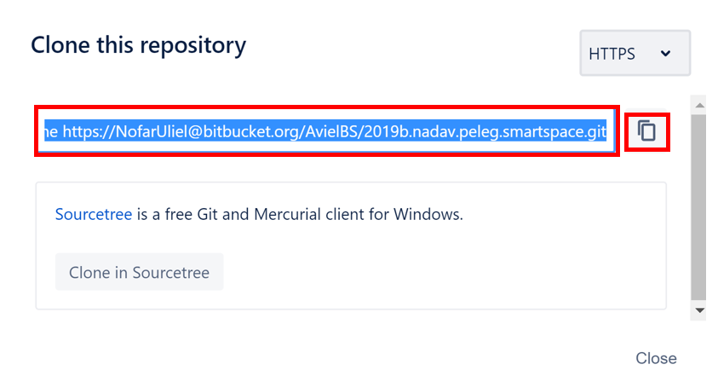

1. Paste it to the URL in the Source Git Repository and fill the

password ->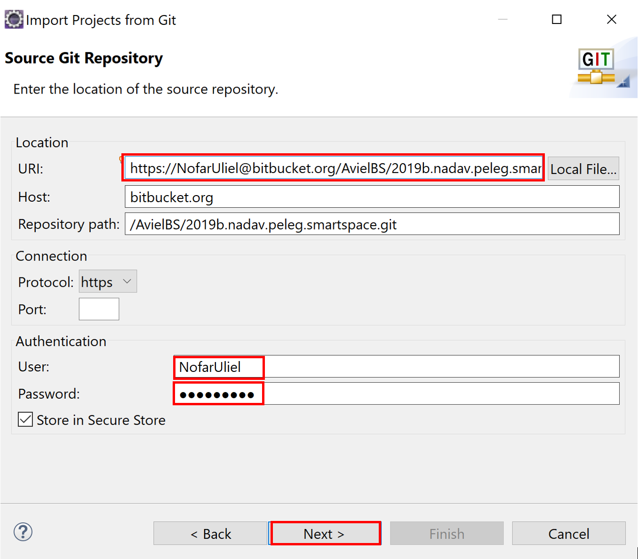

1. Branch Selection - Choose master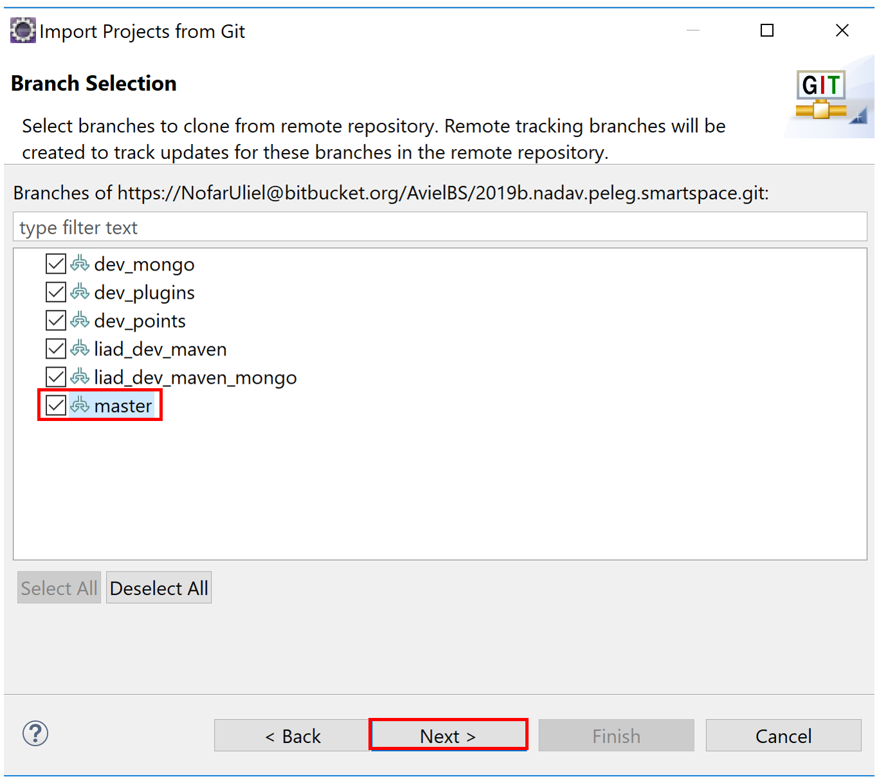
2. Local Destination - Choose Destination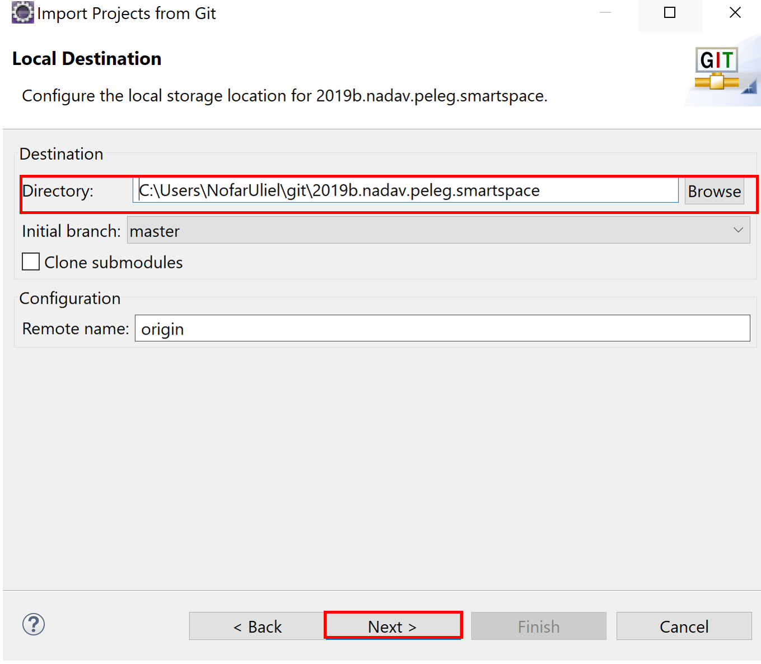
3. Select a wizard to use for importing projects

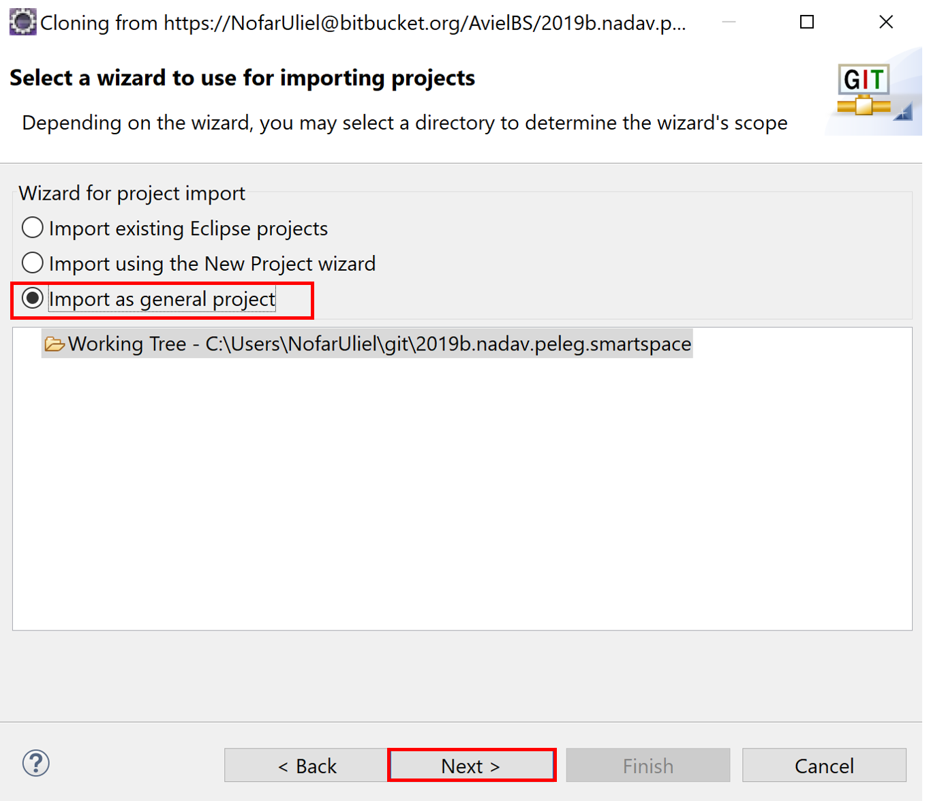

1. Choose name for the project and then click Finish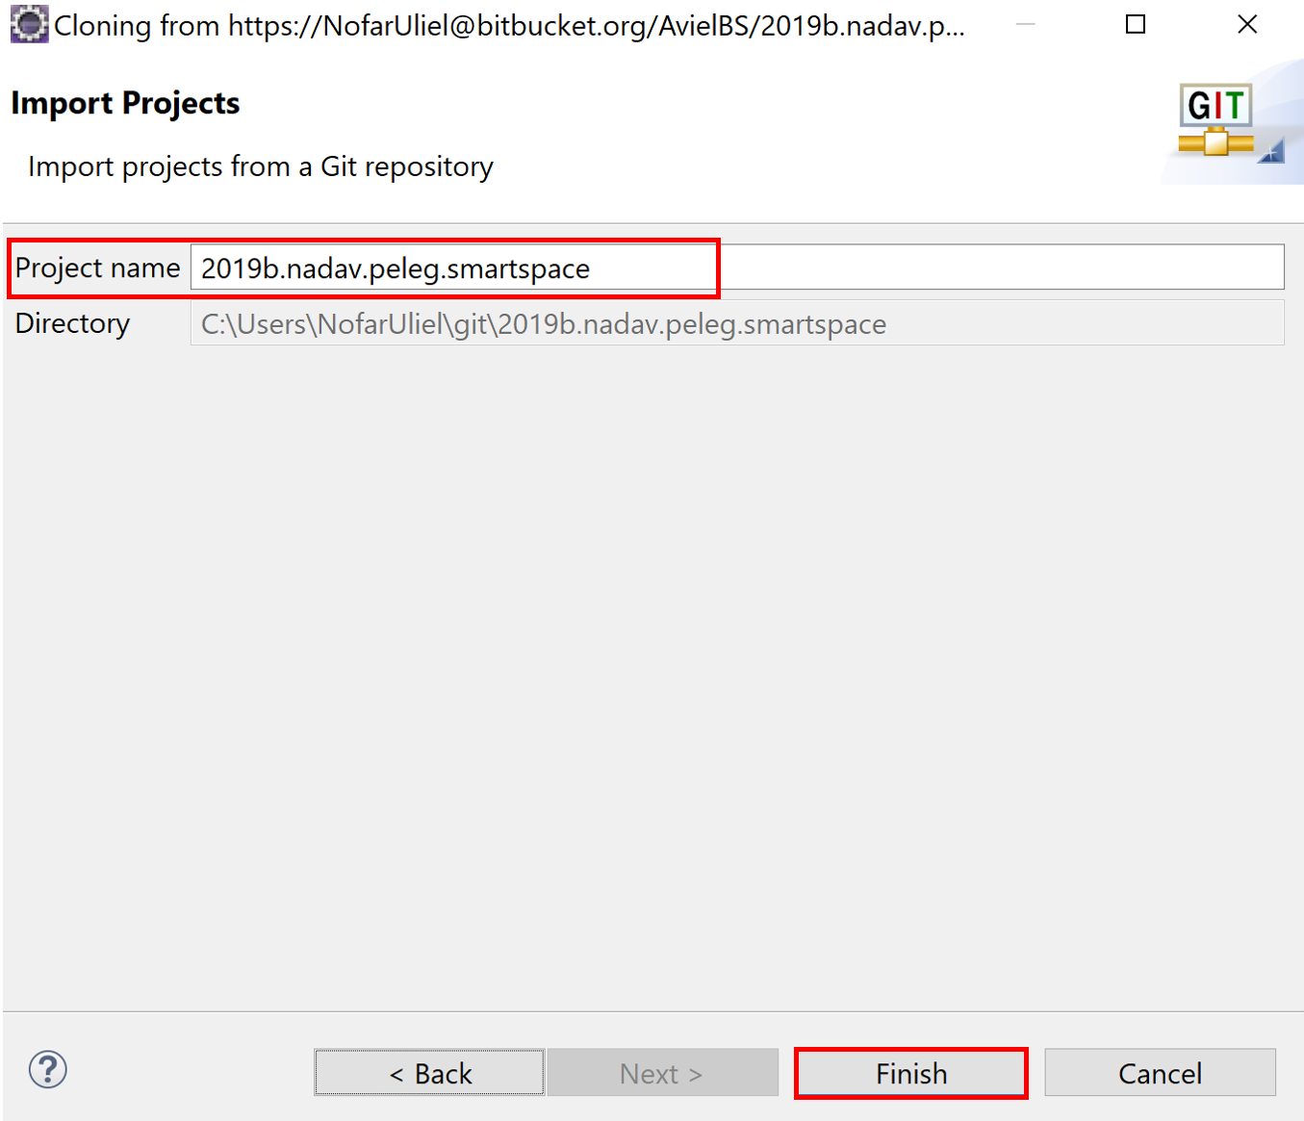
2. Right Click on Project -> Configure -> Convert to Faceted Form

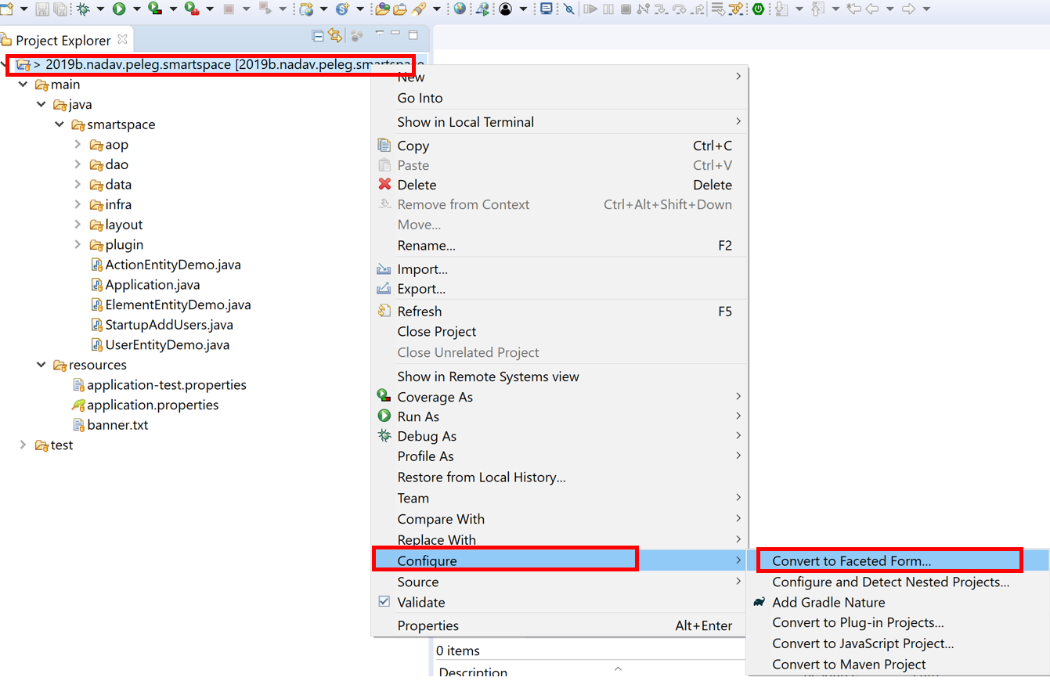

1. Choose Java and then Apply and Close

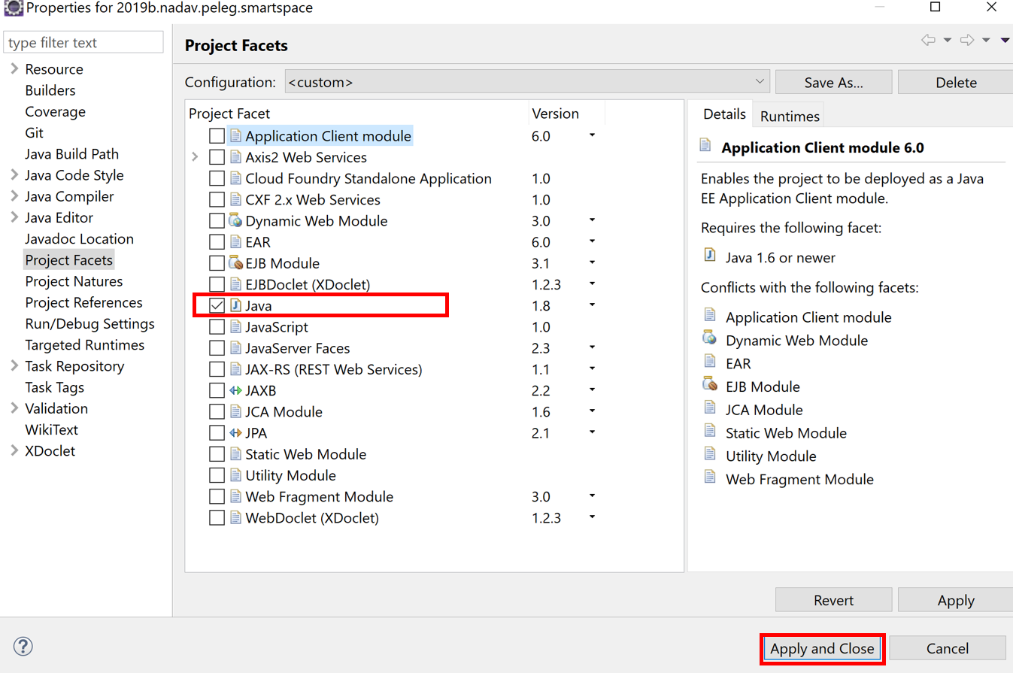

1. Past POM.xml to project directory.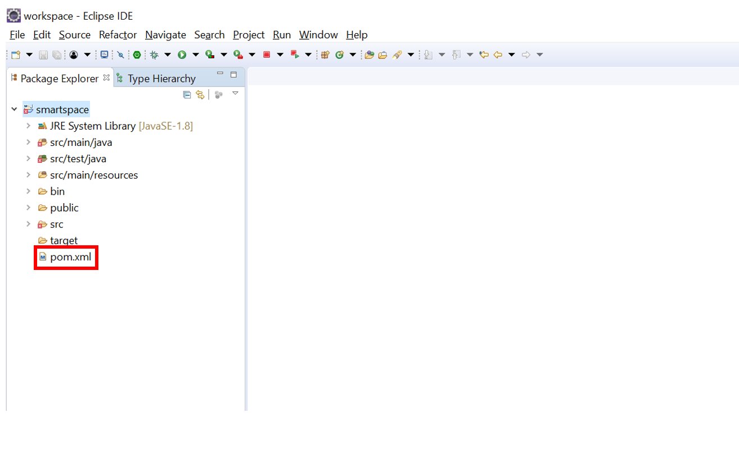
2. Right click on pom.xml->Run As ->Run Configurations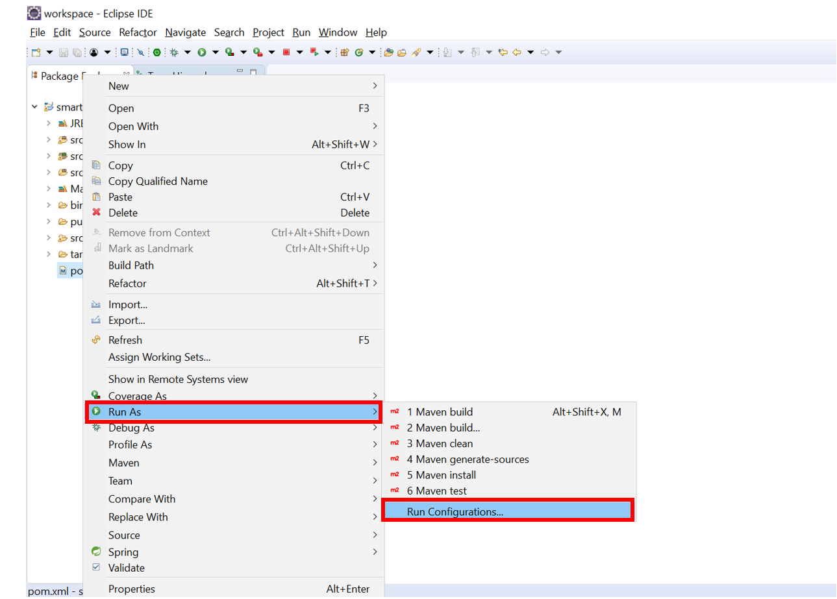
3. Write on Goals: clean install

and click Run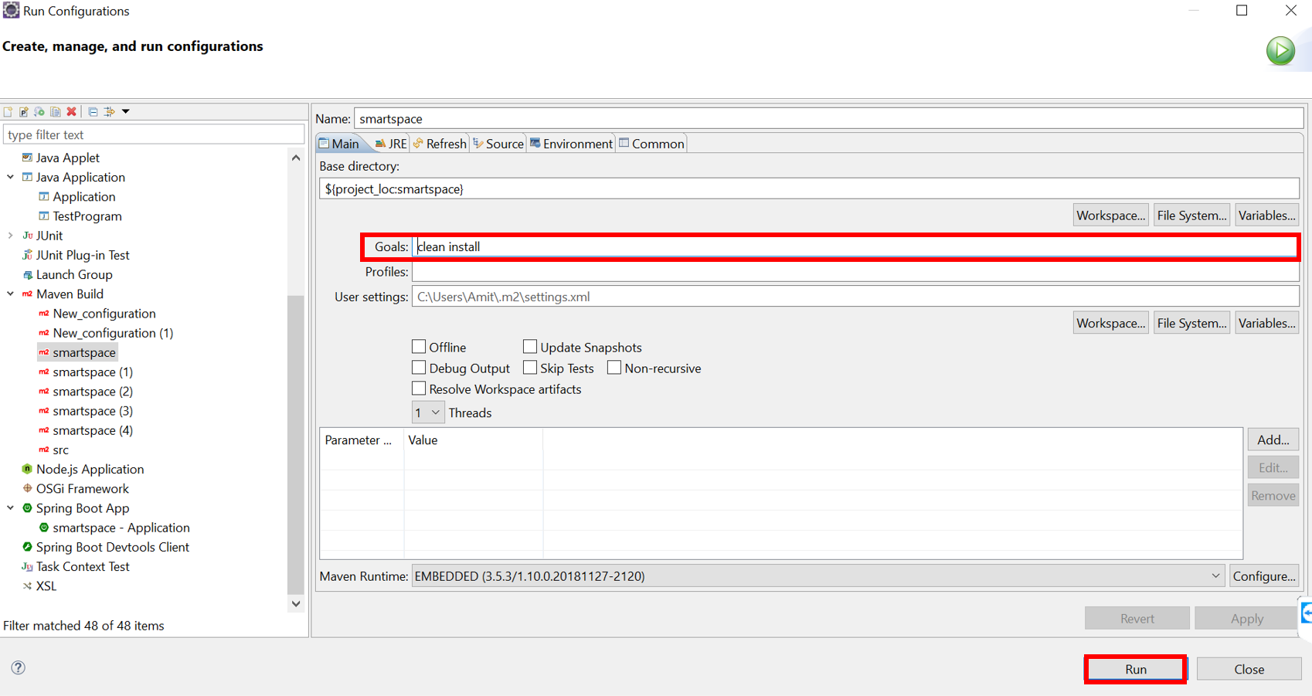

1. Right click on project directory -> Configure -> Convert to Maven Project

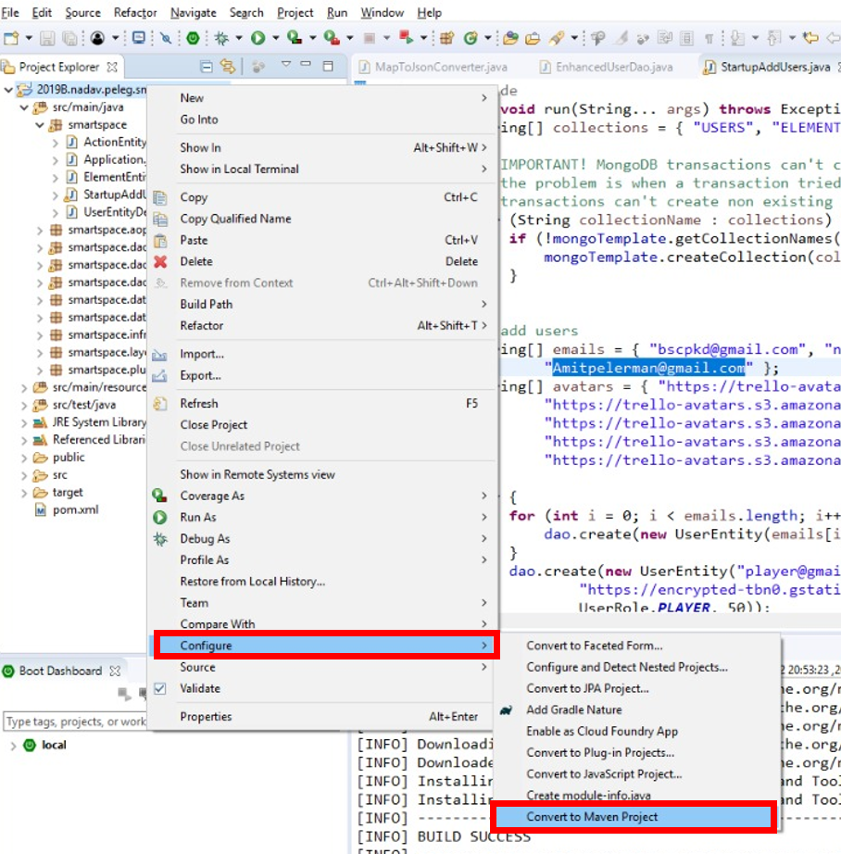

1. Right click on project directory->Maven-> Update Project

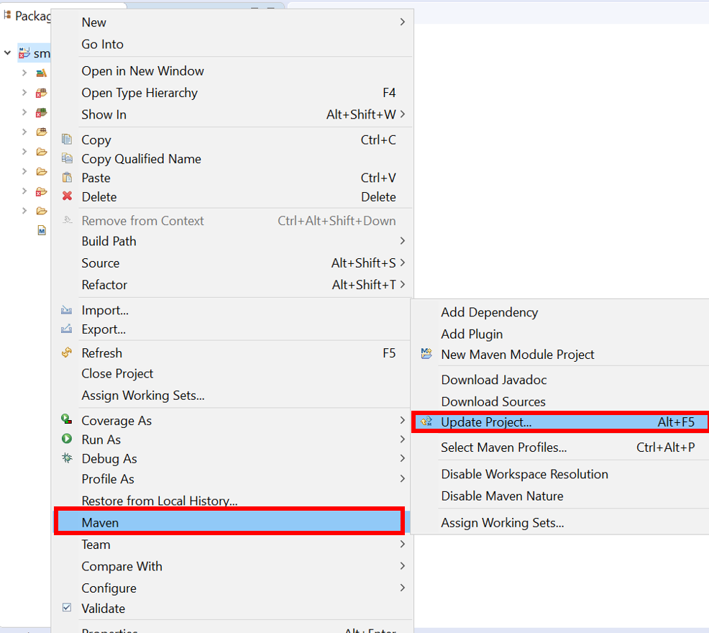

1. Click OK

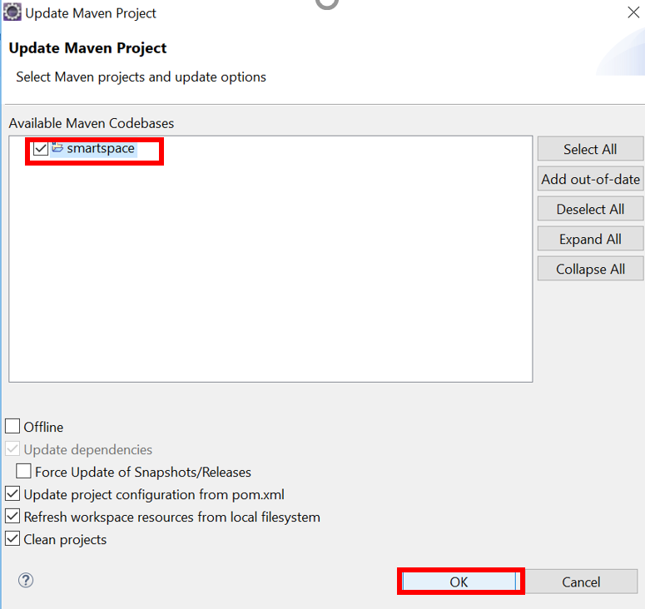

1. Now we don't see any errors because we add to the project Maven Dependencies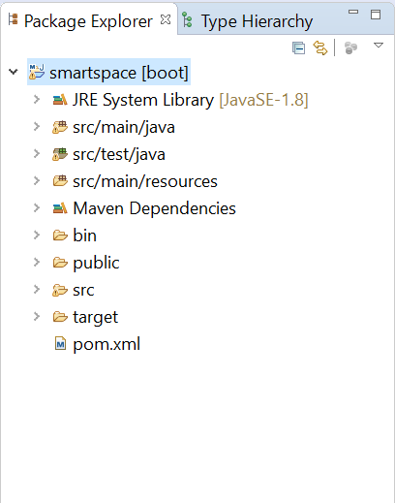

**Congratulation !!!!**

**You have maven project.**

**Enjoy using our app :)**

## *Installing MongoDB*

1. download MongoDB community version by using the following link: <https://fastdl.mongodb.org/win32/mongodb-win32-x86_64-2008plus-ssl-4.0.10.zip>

if the above link doesn’t work anymore just download the latest stable community version from <https://www.mongodb.com/download-center/community>

1. open a new folder under the C:/ or D:/ drive and extract the zip’s content into it.

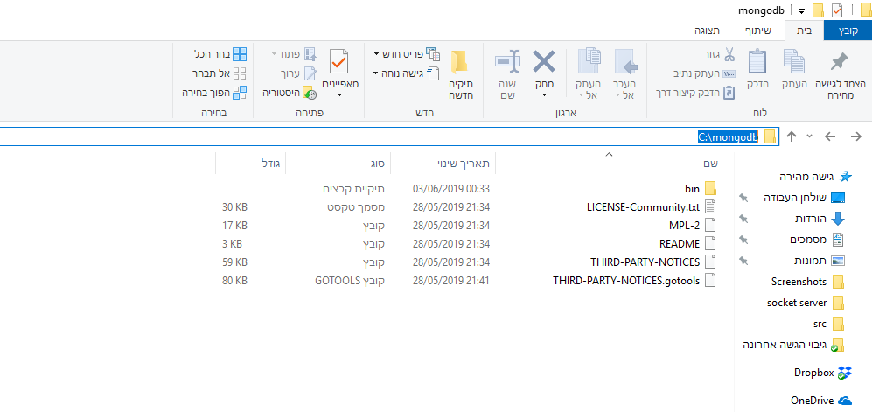

1. open a command line and cd into the bin folder, then run the following command:

*./mongod*

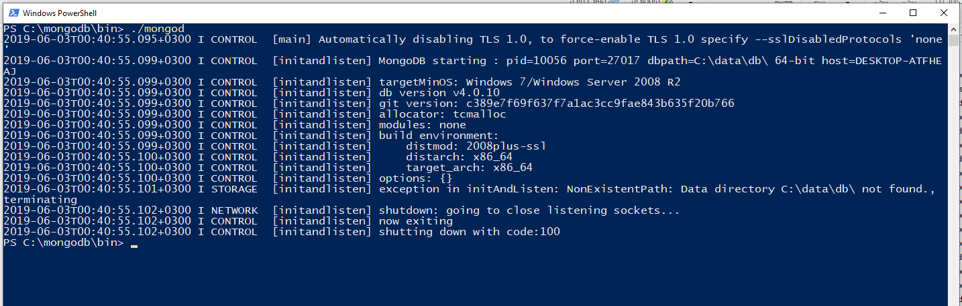

1. You should get the following error:

exception in initAndListen: NonExistentPath: Data directory C:\data\db\ not found., terminating

make sure the requested directory exists and run *./mongod* again, you should now see that MongoDB is waiting for new connections.

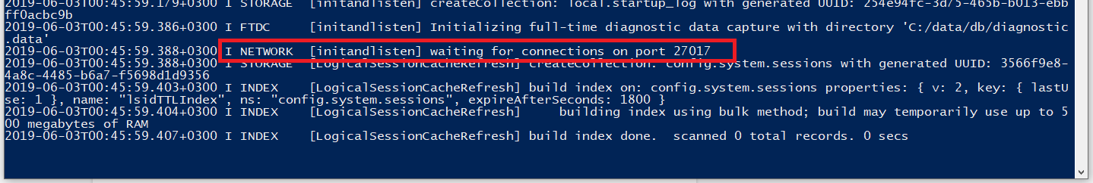

1. MongoDB is now working but we still need to activate sessions or else the @Transctional annotations in our project won’t work as intended, you will get the following warning when running the java server:

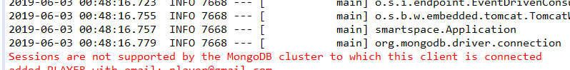

1. stop the server by pressing CTRL + C and run it again by using the command:

*./mongod --replSet “rs0”*

1. open a second command line window and run the following command:

*./mongo --eval "rs.initiate()" -* (don't close the server!)

this command only needs to be used once.

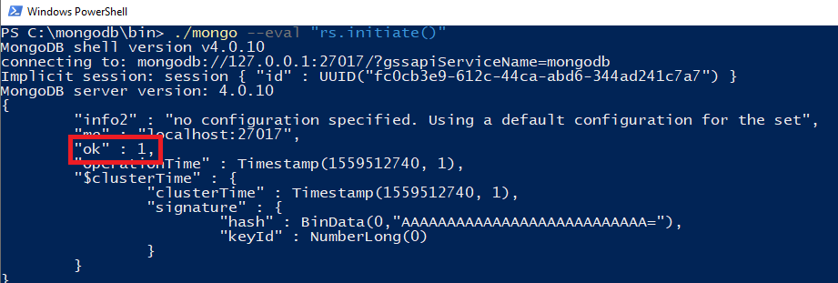

1. You should now see “ok”: 1 meaning the operation was completed successfully.
2. run the java server again, there should be no errors this time!

In addition all tests should now pass.

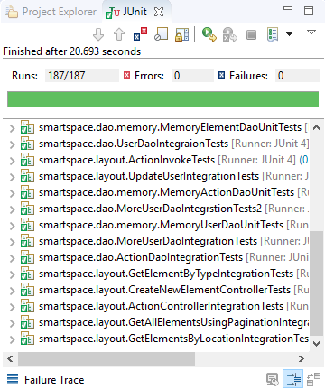

## 

## 

installing mongodb on centos 7 (we installed it on 185.220.207.77:27017):

1. install mongo: <https://www.digitalocean.com/community/tutorials/how-to-install-mongodb-on-centos-7>

2. bind ip to 0.0.0.0 only! <https://www.shellhacks.com/mongodb-allow-remote-access/>

3. open 27017 port: <https://www.thegeekdiary.com/how-to-open-a-ports-in-centos-rhel-7/>

------------------ enable transactions when running as service ------------------

1. add:

bindip 0.0.0.0

and

replication:

replSetName: "rs0"

to the config file at /etc/mongod.conf

2. run mongo --eval "rs.initiate()"

taken from: <https://www.baeldung.com/spring-data-mongodb-transactions>

----------------------- enable transactions from console -----------------------

run with:

1. mongod --replSet rs0 --bind_ip_all

2. nohup mongod --replSet rs0 --bind_ip_all &

(--bind_ip_all to bind it to 0.0.0.0 for remote access)

## 

## *Installing the react web client*

for easy access just put the “public” folder from the zip file in the root folder of your eclipse project. spring will serve the static files on <http://localhost:8080/>.

if you want to run a development react server from the source files follow these steps:

1. download Node.js from the following link: <https://nodejs.org/dist/v10.16.0/node-v10.16.0-x64.msi>

you can alternatively download the latest LTS version from the Node.js website

<https://nodejs.org/en/>

1. follow the installation instructions, just hit next until finished.
2. open a **new** command line window and make sure both node and npm are now installed by using node -v and npm -v.

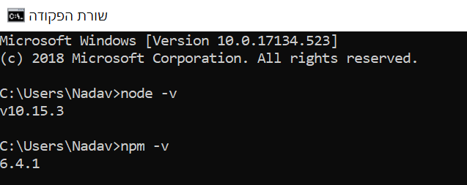

1. install the create-react-app wizard by using npm install -g create-react-app this might take a while.
2. open a new empty directory and cd inside it, then open a new react project with

create-react-app smartspace - this is going to take a very long time to complete!

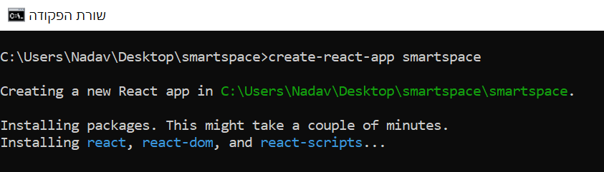

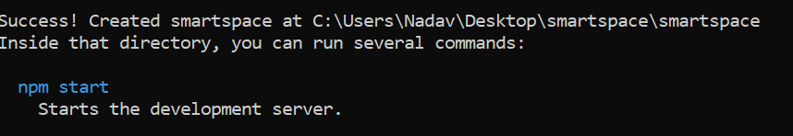

1. to check that everything is connected properly cd into the new directory and the run npm start.
2. after some loading the following window should open in your browser, congrats you have successfully opened a new react project.

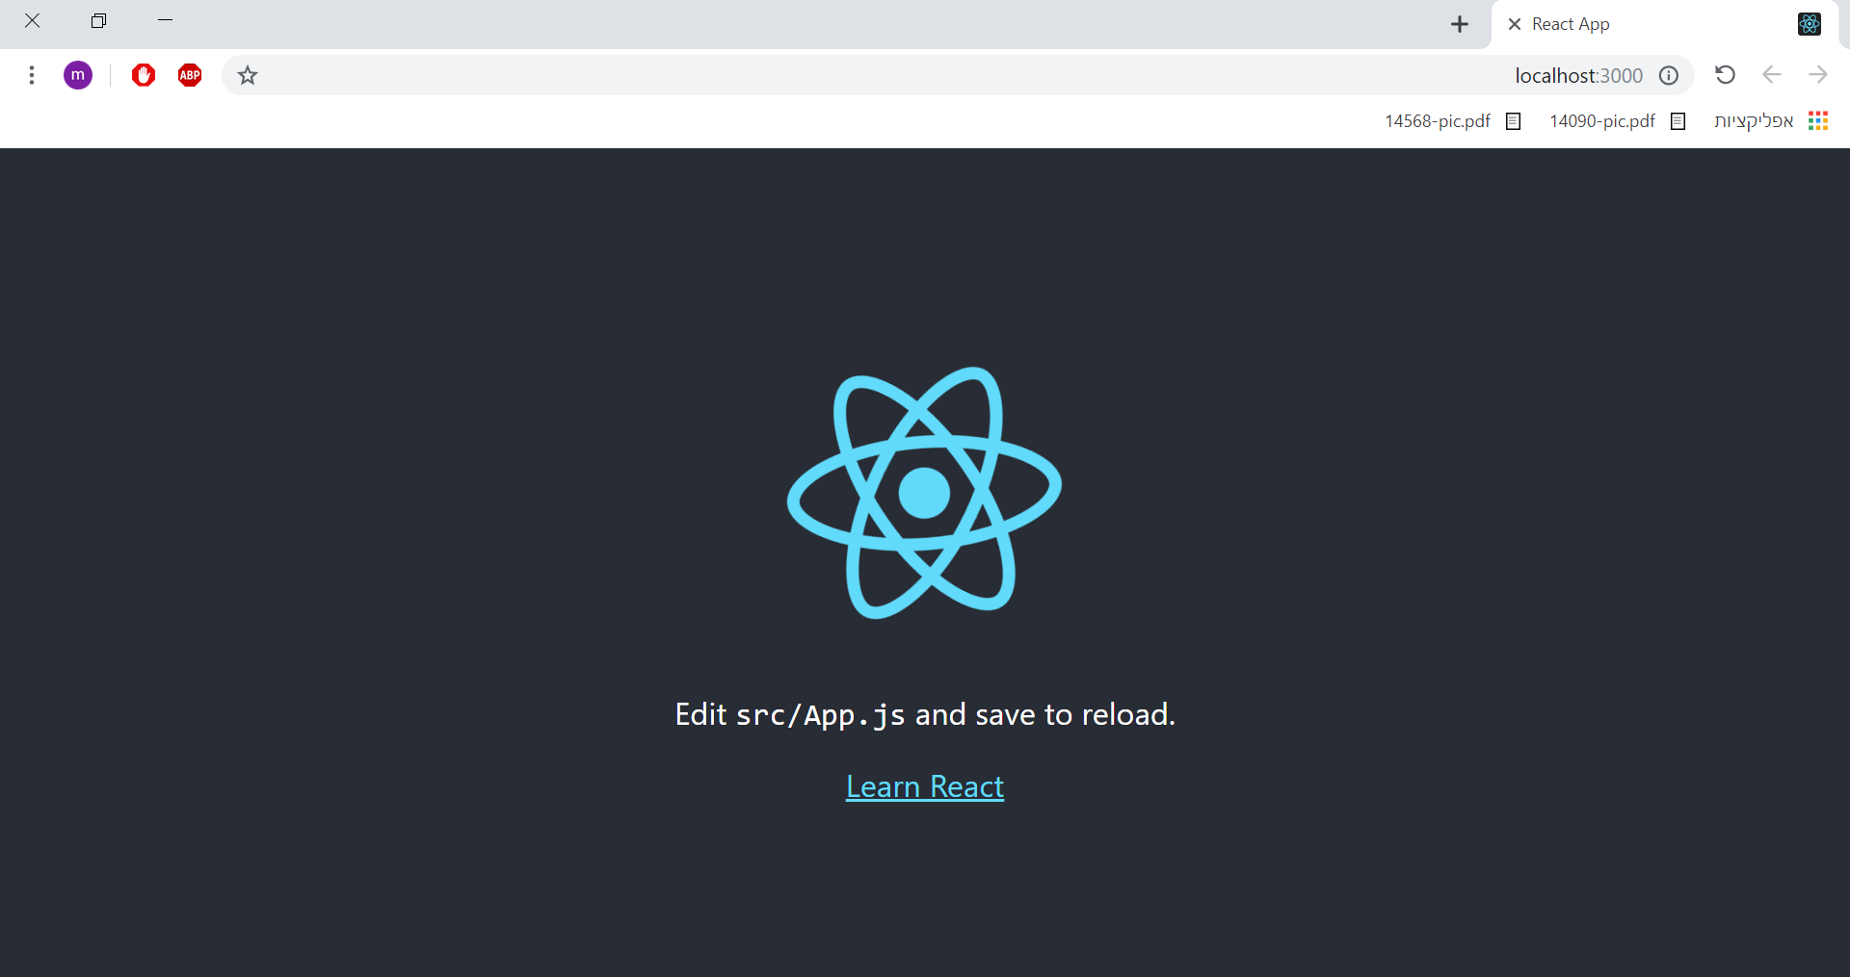

1. stop the react development server by pressing CTRL + C

we will now replace the project source files, start by removing the following folders:

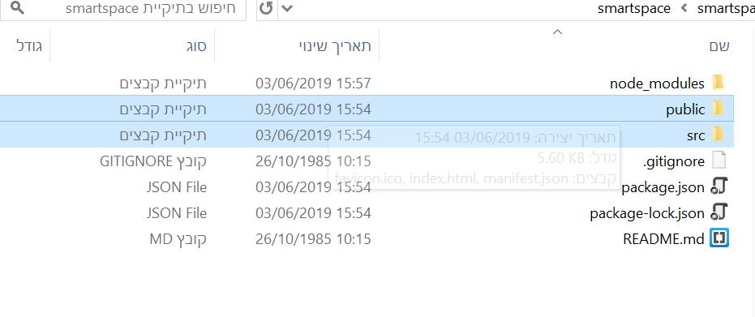

1. in the project submission zip file open the react client folder and extract everything to your react project folder, make sure to use the **replace all** option.

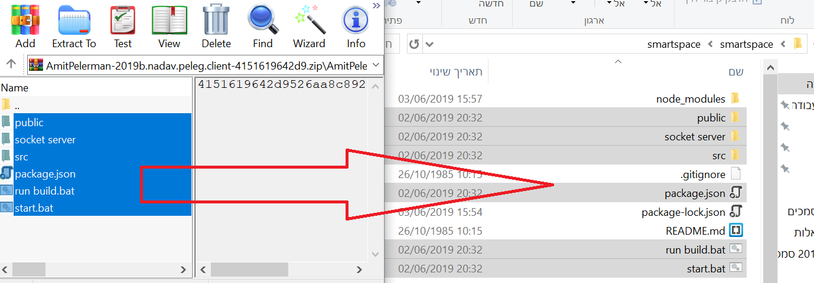

1. to install all required dependencies for our project run npm install this will install all packages specified in our package.json file.



1. run npm start again - everything should work now!

go to [http://localhost:3000/](http://localhost:3000/#/) to enter the login screen.

you can also build the project with npm run build.

## 

## *Installing the socket server*

1. first of all install Node.js by following the “installing react guide”, you should also extract the files from the zip file as explained in step 9.
2. open a command line and cd into the “socket server” folder

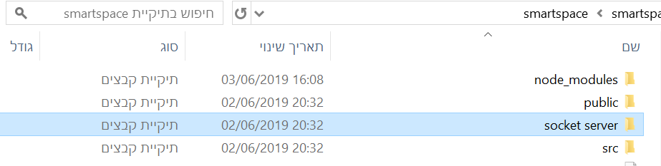



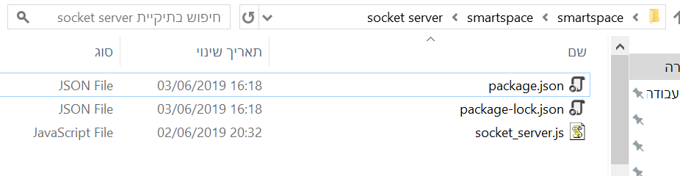

1. to install all required dependencies for the socket server run npm install this will install all packages specified in the package.json file.

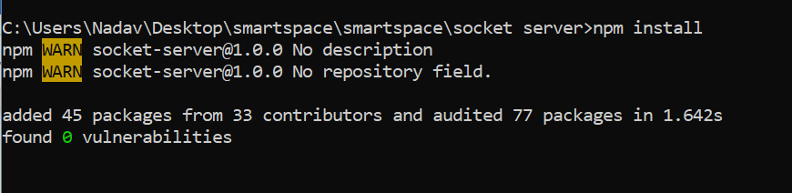

1. you can now run the socket server with node socket_server.js.

clients will now be able to connect to the socket server running on localhost:8000

## 

## 

Installing the socket server on CentOS 7 (we installed it on 185.220.207.77:**8000**):

1. install Node.js:

<https://www.digitalocean.com/community/tutorials/how-to-install-node-js-on-a-centos-7-server>

2. deploy node server:

<https://www.digitalocean.com/community/tutorials/how-to-set-up-a-node-js-application-for-production-on-centos-7>

## 

## *Installing the android client*

1. Install android studio:

<https://www.youtube.com/watch?v=JVhlL967G7s>

<https://www.youtube.com/watch?v=7vvMltQtfxY>

1. Import android studio project from github:

the git repository is: <https://github.com/LiadKh/SmartspaceAdminClient>

you should follow these guides:

<https://www.youtube.com/watch?v=wenTzCZpv90>

<https://www.youtube.com/watch?v=Y6gmmQZsuLE>

## 

## *Additional configurations for client and server*

*Configuring the database connection*

We installed a MongoDB server on the cloud that should be running on 185.220.207.77:27017

if the server is not active anymore go to the *application.properties* file in the root folder of the java project and comment out the following line:



the server will now try to use MongoDB running at localhost.

*Configuring client connection to java server (ip + port)*

In the clients we made sure to request the server’s IP and Port from the user, when you are in the login menu you can type in the details of the server you want to connect to.

by default our server runs on localhost with port 8080

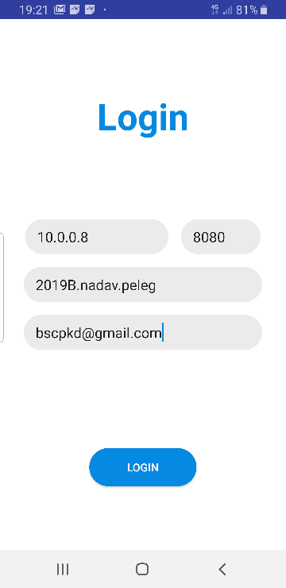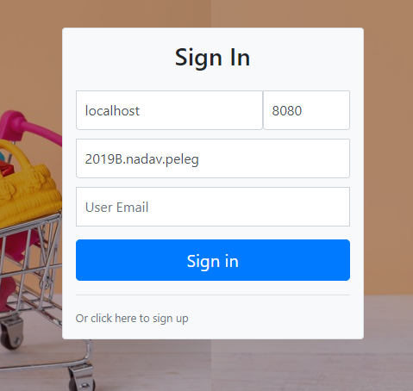

# 

# 

*Configuring socket connection for the web client (ip + port)*

Open the web client and log in, under the user menu click “Sockets” 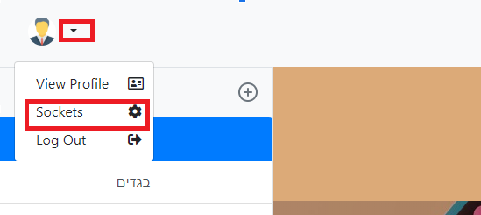

Type the socket server details and click “save”

You can use the socket server running on ip 185.220.207.77 and port **8000.**

if the cloud socket server isn’t active anymore run a local server by following the instructions already given above under “installing the socket server”.

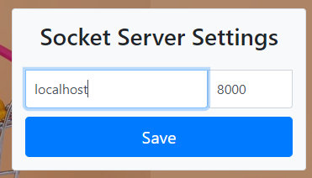

After clicking the save button you will get a message, refresh the page if requested.

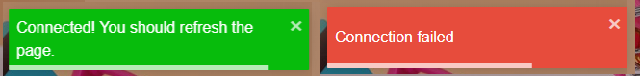

**Running a socket server is optional and the web client will still work without it! however you must use a socket server if you want to receive live updates from other clients.**

**(for test purposes open multiple tabs on different logins to simulate multiple users)**

# 

# 6. Appendix E - Clients Screenshots

## *Web Client - For Players and Managers*

Sign in and registration

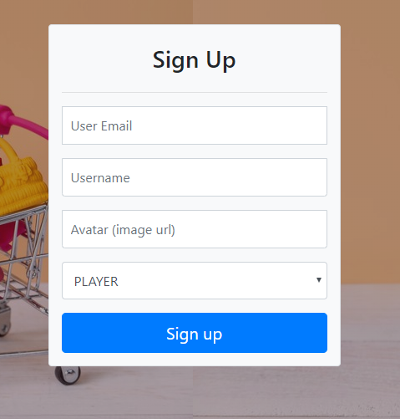

Main screen

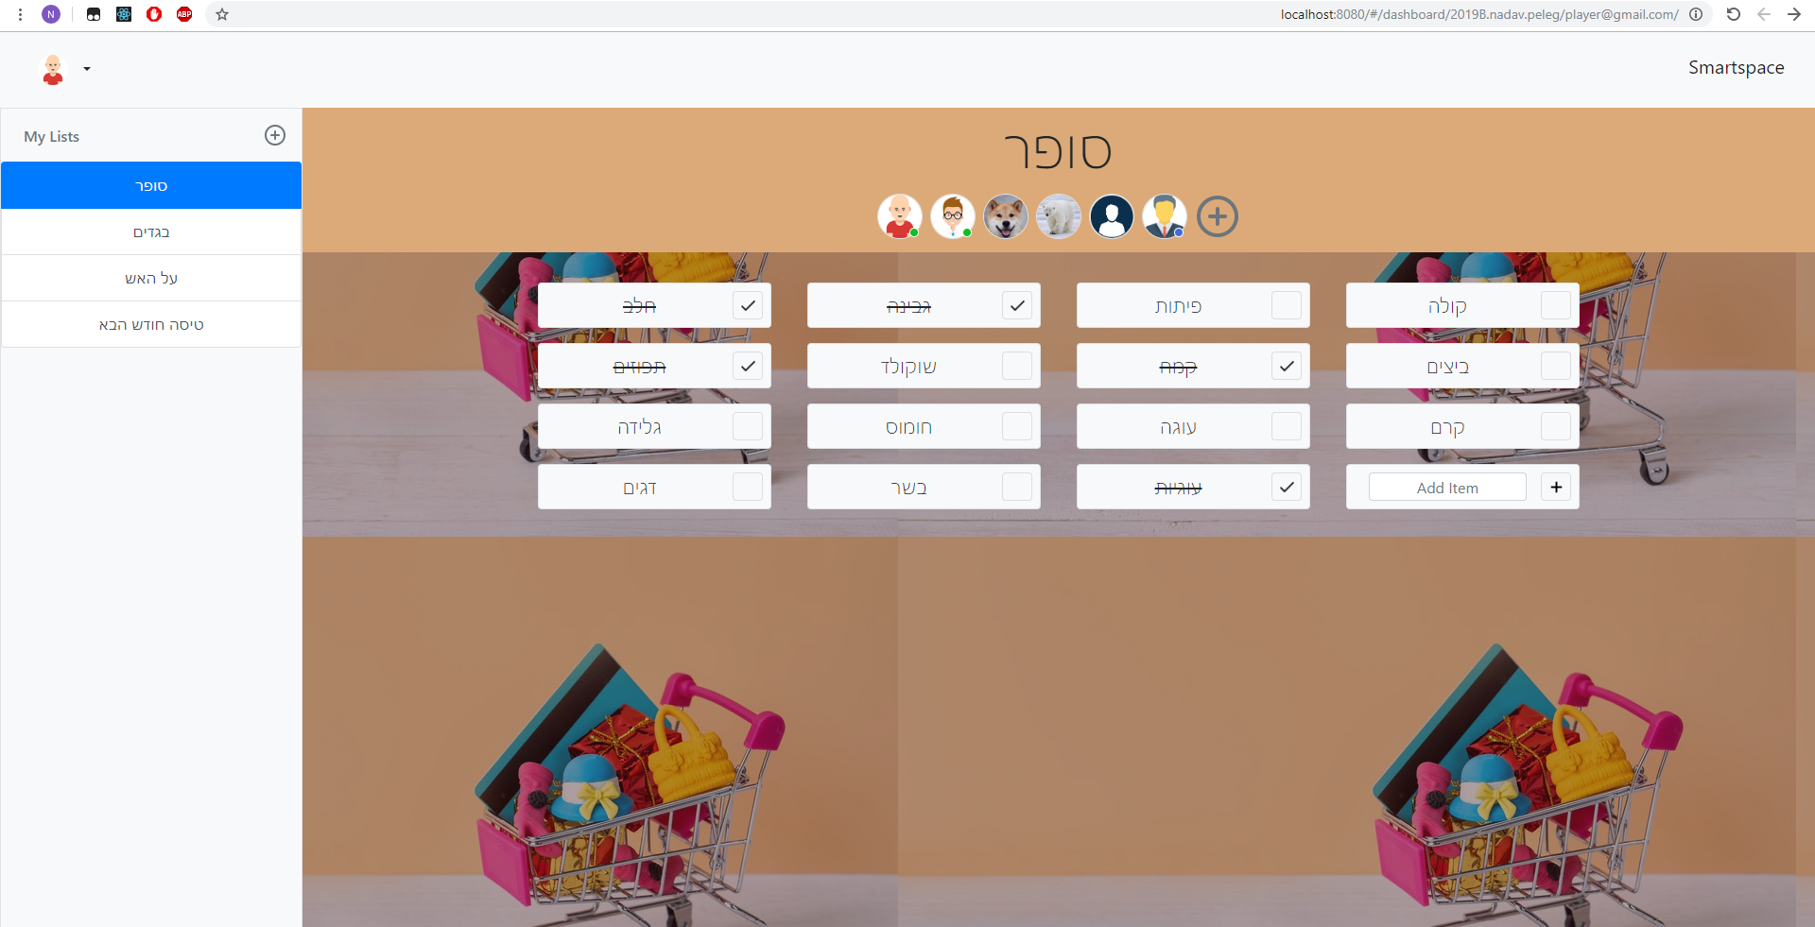

Navbar Menu

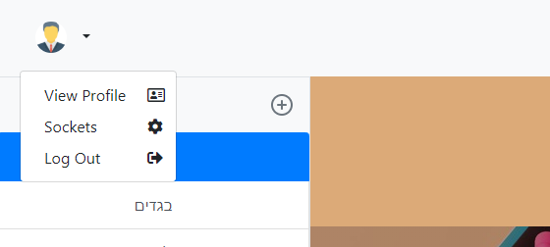

Profile edit

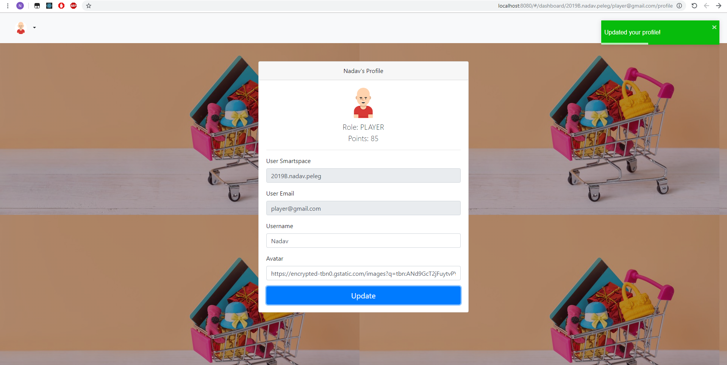

Create a new Item

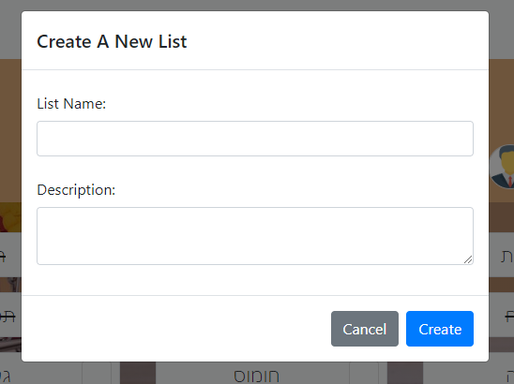

Item added successfully

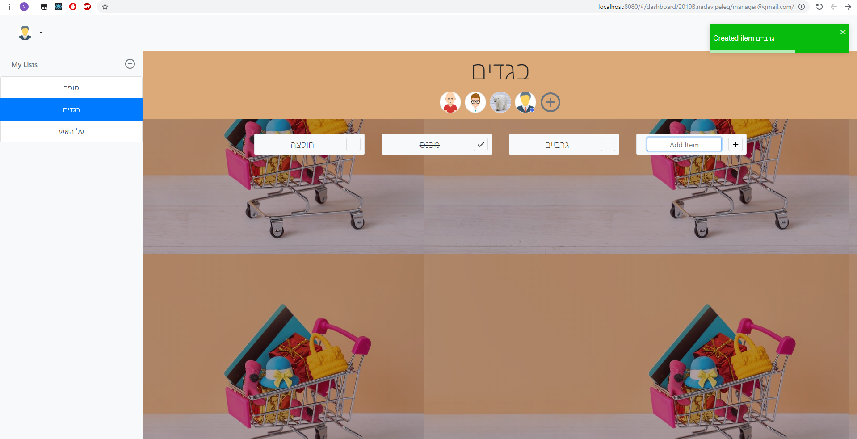

Add new member to shopping list

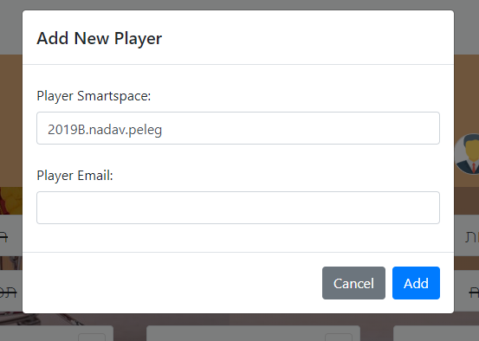

Marking item as bought



Trying to create a list or item as a player

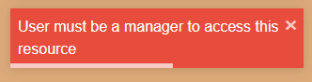

Trying to mark item as bought as a manager

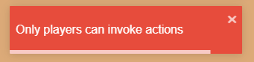

## *Android Client - For Admins*

Login Screen



Main Screen

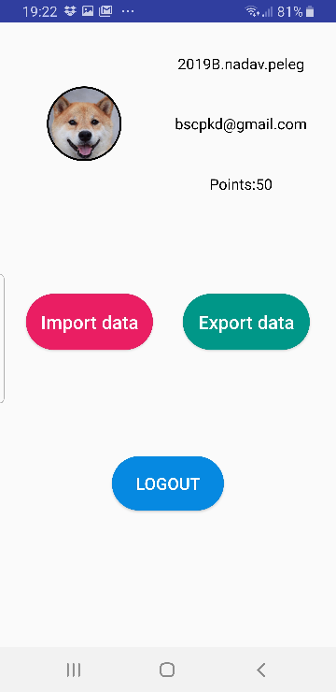

Export / Import screen

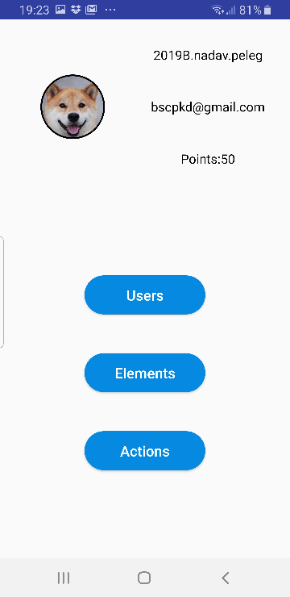

After selecting to export (Android Share)

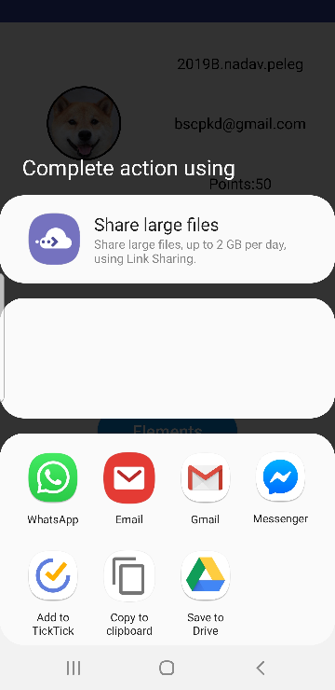

After selecting to import (Android select files menu)

